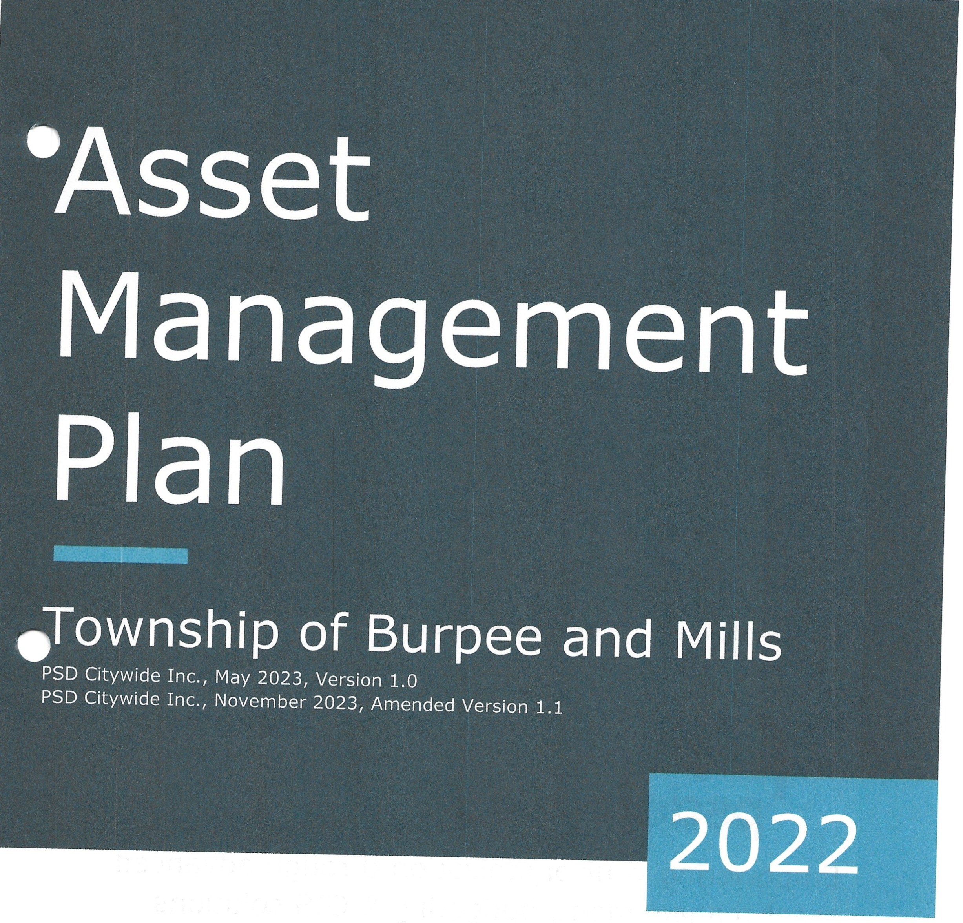

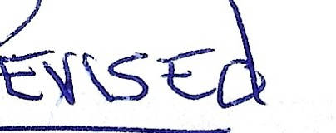

This Asset Management Program was prepared by:

TM
psdcitywide
Empowering your organization through advanced asset management, budgeting & GIS solutions

,-/·!I,.

Replacement cos? of asset portfolio
$32. 9 million
Replacement cost of infrastructure per household
$112kc2021)

Percentage of assets in fair or better condition
95°10

Percentage of assets with assessed condition data
95°10

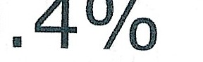

Annual capital infrastructure deficit
Recommended timeframe for eliminating annual infrastructure deficit
20 Years
Target reinvestment
rate
2.2%
:
I

Actual reinvestment rate

=�
Jil·

Table of Contents
'·
Executive Summary 1
Scope 1
Findings 2
Recommendations 3
- Introduction & Context .................................L 4
:\
  - Burpee and Mills Community Profile 5
  - An Overview of Asset Management 6
  - Key Concepts in Asset Management 8
  - Climate Change 11
  - Ontario Regulation 588/17 ..........................:. 14
- Scope and Methodology ............................... /, 16
  - Asset Categories Included in this AMP 17
  - Deriving Replacement Costs 17
  - Estimated Useful Life and Service Life Remaining 18
  - Reinvestment Rate 18
  - Deriving Asset Condition .............................,::.···· 19
- Portfolio Overview 20
  - Total Replacement Cost of Asset Portfolio 21
  - Condition of Asset Portfolio 22
  - Forecasted Capital Requirements 23
  - Target vs. Actual Reinvestment Rate 23
- Analysis of Tax-funded Assets........................; 25
  - Road Network 26
  - Culverts 39
  - Buildings .............................................,, 48
  - Vehicles 54
  - Land Improvements 60
  - Machinery & Equipment ..................................,· 66
- Impacts of Growth 72
  - Description of Growth Assumptions 73
  - Impact of Growth on Lifecycle Activities 76

- Financial Strategy 77
  - Financial Strategy Overview 78
  - Funding Objective 80
  - Financial Profile: Tax Funded Assets 81
  - Use of Reserves 84
- Appendices 86
  - Appendix A: 10-Year Capital Requirements 87
  - Appendix B: Level of Service Maps 90
  - Appendix C: Risk Rating Criteria 91
  - Appendix D: Condition Assessment Guidelines 93
  - Appendix E: 10-Year Replacement List 95

Executive Summary
Municipal infrastructure provides the foundation for the economic, social, and·environmental health and growth of a community through the delivery of critical services. The goal of asset management is to deliver an adequate level of service in the most cost-effective manner. This involves the development and implementation of asset management strategies and long­ term financial planning.

Scope
This AMP identifies the current practices and strategies that are in place to manage public infrastructure and makes recommendations where they can be further refined. Through the implementation of sound asset management strategies, the Township can ensure that public infrastructure is managed to support the sustainable delivery of municipal services.

This AMP include the following asset categories:
® Road Network
@vehicles
Asset Category
®
Culverts
0 Land Improvements
®
@ Buildings
Machinery & Equipment

With the development of this AMP the Township has achieved compliance with 0. Reg. 588/17 to the extent of the requirements that must be completed by July 1, 2022. There are additional requirements concerning proposed levels of
... service and growth that must be met by July 1, 2025.

Findings
The overall replacement cost of the asset categories included in this AMP totals $32.9 million. 95% of all assets analysed in this AMP are in fair or better condition and assessed condition data was available for 95% of assets. For the remaining 5% of assets, assessed condition data was unavailable, and asset age was used to approximate condition - a data gap that persists in most municipalities. Generally, age misstates the true condition of assets, making assessments essential to accurate asset management planning, and a recurring recommendation in this AMP.
The development of a long-term, sustainable financial plan requires an
- analysis of whole lifecycle costs. This AMP uses a combination of proactive lifecycle strategies (LCB roads and gravel roads) and replacement only strategies (all other assets) to determine the lowest cost option to maintain the current level of service.

To meet capital replacement and rehabilitation needs for existing infrastructure, prevent infrastructure backlogs, and achieve long-term sustainability, the Township's average annual capital requirement totals
$719,000. It is important to note that this AMP represents a snapshot in time and is based on the best available processes, data, and information at the Township. Strategic asset management planning is an ongoing and dynamic process that requires continuous improvement and dedicated resources.

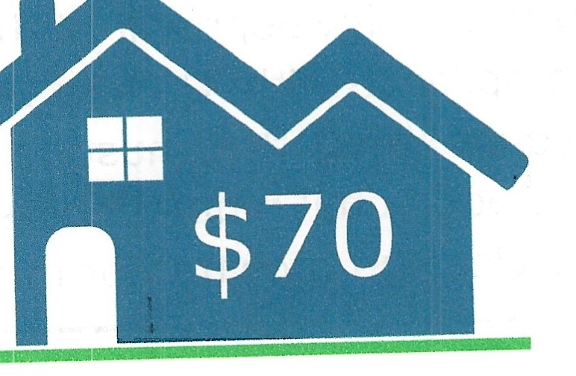
Average Annual Increase Per Household

Recommendations
A financial strategy was developed to addrnss the annual capital funding gap. The following graphics shows annual tax/rate change required to eliminate the Township's infrastructure deficit based on a 20-year plan:

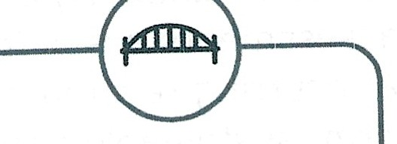

Tax-Funded
ASSETS

Average Annual Tax Change
2.8%

Recommendations to guide continuous refinement of the Township's asset management program. These include:
- Review data to update and maintain a complete and accurate dataset
- Review estimated useful life to reflect true service life as utilized by staff
- Develop a condition assessment strategy with a regular schedule
- Review and update lifecycle management strategies
- Development and regularly review short- and long-term plans to meet capital requirements
- Measure current levels of service and identify sustainable proposed levels of service

Introduction & Context

Key Insights

- The goal of asset management is to minimize the lifecycle costs of delivering infrastructure services, manage the associated risks, while maximizing the value ratepayers receive from the asset portfolio

- The Township's asset management policy provides clear direction to staff on their roles and responsibilities regarding asset management

- An asset management plan is a living document that should be updated regularly to inform long-term planning

- Ontario Regulation 588/17 outlines several key milestone and requirements for asset management plans in Ontario between July 1, 2022 and 2025

Burpee and Mills Community Profile

 | Census Characteristic | Burpee and Mills | Ontario
 | Population 2021 | 382 | 14,223,942
 | Population Change 2016-2021 | 11.4 | 5.8
 | Total Private Dwellings | 292 | 5,929,250
 | Population Density | 1.8 | 15.9
 | Land Area In Square Kilometers | 217.33 | 892,411.76
The Township of Burpee and Mills is located in Western Manitoulin Island of the Northeastern Ontario. The Township is located along Lake Huron and other inland lakes. It is comprised of the communities of Burpee, Elizabeth Bay, Evansville, and Poplar. The Township is formed in 1998 through the annexation the Township of Mills by the Township of Burpee.

In 1870s, a number of settlers landed in Burpee and Mills and created family farms. Since then, Burpee and Mills maintains its rural character and stays as a close community. Current employment opportunities are primarily based on tourism, agriculture, aquaculture, and logging. Tourism is the largest economic sector of the Township due to its unique location and attraction. The Township will continue to promote tourism while protecting the environment, diversifying the economy, and fostering social integration and healthy lifestyles for residents.

Demand in the Township is notably driven by population growth and an aging population above the provincial average. The population has increased by 11.4% since 2016. The Official Plan for the District of Manitoulin establishes policies to guide the distribution of land uses and development of infrastructure with respect to the health, convenience and economic well--being of residents, business, and visitors.

Municipal staff have identified the road network as the primary infrastructure priority. Staff are aiming to maintain a high level of service through a series of rehabilitation and replacement projects. Risk-based project prioritization is essential for capital planning since major infrastructure projects are heavily reliant on the availability of grants. Staff hope to support continuous growth by investing in critical infrastructure and advancing their asset management program.

5

An Overview of Asset Management
Municipalities are responsible for managing and maintaining a broad portfolio of infrastructure assets to deliver services to the community. The goal of asset management is to minimize the lifecycle costs of delivering infrastructure services, manage the associated risks, while maximizing the value ratepayers receive from the asset portfolio.

The acquisition of capital assets accounts for only 10-20% of their total cost of ownership. The remaining 80-90% derives from operations and maintenance. This AMP focuses its analysis on the capital costs to maintain, rehabilitate and replace existing municipal infrastructure assets.

Total Cost of Ownership

Build 20%
[

Operate, Maintain, and Dispose 80%
l

These costs can span decades, requiring planning and foresight to ensure financial responsibility is spread equitably across generations. An asset management plan is critical to this planning, and an essential element of broader asset management program. The industry-standard approach and sequence to developing a practical asset management program begins with a Strategic Plan, followed by an Asset Management Policy and an Asset Management Strategy, concluding with an Asset Management Plan.

This industry standard, defined by the Institute of Asset Management (1AM), emphasizes the alignment between the corporate strategic plan and various asset management documents. The strategic plan has a direct, and cascading impact on asset management planning and reporting.

6

Asset Management Policy
An asset management policy represents a statement of the commitment to the development and implementation of the Township of Burpee and Mills' asset management program. It guides the organization-wide.asset management activities, facilitate logical and evidence-based decision making for the management of municipal infrastructure assets and to support the delivery of sustainable community services.

The Township adopted the Asset Management Policy in accordance with Ontario Regulation 588/17 in August 2020.

The approval of this policy is important to integrate the Township's strategic mission, vision and goals with its asset management program, and ensuring the critical municipal infrastructure assets and vital services are maintained and provided to the community in a reliable, sustainablEi manner. The essential services include transportation networks, facilities and parks and other infrastructure.

Asset Management Strategy
An asset management strategy outlines the translation of organizational objectives into asset management objectives and provides a strategic overview of the activities required to meet these objectives. It provides greater detail than the policy on how the Township plans to achieve asset management objectives through planned activities and decision-making criteria. The Township's Asset Management Policy contains many of the key components of an asset management strategy and may be expanded on in future revisions or as part of a separate strategic document.

Asset Management Plan
The asset management plan (AMP) presents the outcomes of the Township's asset management program and identifies the resource requirements needed to achieve a defined level of service. The AMP typically includes the following content:
      - State of Infrastructure
      - Asset Management Strategies
      - Levels of Service
      - Financial Strategies
The AMP is a living document that should be updated regularly as additional asset and financial data becomes available. This will allow the Township to re-evaluate the state of infrastructure and identify how the orqanization's asset management and financial strategies are progressing.

7

.,,-...

Key Concepts in Asset Management

Effective asset management integrates several key components, including lifecycle management, risk management, and levels of service. These concepts are applied throughout this asset management plan and are described below in greater detail.

Lifecycle Management Strategies
The condition or performance of most assets will deteriorate over time. This process is affected by a range of factors including an asset's characteristics, location, utilization, maintenance history and environment. Asset deterioration has a negative effect on the ability of an asset to fulfill its intended function, and may be characterized by increased cost, risk and even service disruption.

To ensure that municipal assets are performing as expected and meeting the needs of customers, it is important to establish a lifecycle management strategy to proactively manage asset deterioration.

There are several field intervention activities that are available to extend the life of an asset. These activities can be generally placed into one of three categories: maintenance, rehabilitation and replacement. The following table provides a description of each type of activity and the general difference in cost.

Lifecycle Description Example Cost
Activity (Roads)

$
Maintenance | Activities that prevent defects or deteriorations from occurring | Crack Seal
 | Activities that rectify defects or
Rehabilitation/ | deficiencies that are already | Mill & Re-
Renewal | present and may be affecting | surface
 | asset performance

$$

Replacement/ Asset end-of-life activities that Full

Reconstruction
often involve the complete replacement of assets
Reconstruction
$$$

Depending on initial lifecycle management strategies, asset performance can be sustained through a combination of maintenance and rehabilitation, but at some point, replacement is required. Understanding what effect these activities will have on the lifecycle of an asset, and their cost, will enable staff to make better recommendations.

8

The Township's approach to lifecycle management is described within each asset category outlined in this AMP. Developing and implementing a proactive lifecycle strategy will help staff to determine which activities to perform on an asset and when they should be performed to maximize useful life at the lowest total cost of ownership.

Risk Management Strategies
Municipalities generally take a 'worst-first' approach to infrastructure spending. Rather than prioritizing assets based on their importance to service delivery, assets in the worst condition are fixed first, regardless of their criticality. However, not all assets are created equal. Some are more important than others, and their failure or disrepair poses more risk to the community than that of others. For example, a road with a high volume of traffic that provides access to critical services poses a higher risk than a low volume rural road. ThesE? high-value assets should receive funding before others.

By identifying the various impacts of asset failure and the likelihood that it will fail, risk management strategies can identify critical assets, and determine where maintenance efforts, and spending, should be focused.

This AMP includes a high-level evaluation of asset risk and criticality. Each asset has been assigned a probability of failure score and consequence of failure score based on available asset data. These risk scores can be used to prioritize maintenance, rehabilitation and replacement strategies for critical assets.

Levels of Service
A level of service (LOS) is a measure of what the Township is providing to the community and the nature and quality of that service. Within each asset category in this AMP, technical metrics and qualitative descriptions that measure both technical and community levels of service have been established and measured as data is available.

These measures include a combination of those that have been outlined in 0. Reg. 588/17 in addition to performance measures identified by the Township as worth measuring and evaluating. The Township measures the level of service provided at two levels: Community Levels of Service, and Technical Levels of Service.
Community Levels of Service
Community levels of service are a simple, plain language description or measure of the service that the community receives. For core asset categories (roads, bridges and culverts, water, wastewater, stormwater) the Province, through 0. Reg.
588/17, has provided qualitative descriptions that are required to be included.in
9

this AMP. For non-core asset categories, the Township has determined the qualitative descriptions that will be used to determine the community level of service provided. These descriptions can be found in the Levels of Service subsection within each asset category.
Technical Levels of Service
Technical levels of service are a measure of key technical attributes of the service being provided to the community. These include mostly quantitative measures and tend to reflect the impact of the Township's asset management strategies on the physical condition of assets or the quality/capacity of the services they provide.

For core asset categories (roads, bridges and culverts, water, wastewater, stormwater) the Province, through 0. Reg. 588/17, has provided technical metrics that are required to be included in this AMP. For non-core asset categories, the Township has determined the technical metrics that will be used to determine the technical level of service provided. These metrics can be found in the Levels of Service subsection within each asset category.
Current and Proposed Levels of Service
This AMP focuses on measuring the current level of service provided to the community. Once current levels of service have been measured, the Township plans to establish proposed levels of service over a 10-year period, in accordance with 0. Reg. 588/17.

Proposed levels of service should be realistic and achievable within the timeframe outlined by the Township. They should also be determined with consideration of a variety of community expectations, fiscal capacity, regulatory requirements, corporate goals and long-term sustainability. Once proposed levels of service have been established, and prior to July 2025, the Township must identify a lifecycle management and financial strategy which allows these targets to be achieved.

10

Climate Change
Climate change can cause severe impacts on human and natural systems around the world. The effects of climate change include increasing temperatures, higher levels of precipitation, droughts, and extreme weather events. In 2019, Canada's Changing Climate Report (CCCR 2019) was rel.eased by Environment and Climate Change Canada (ECCC).

The report revealed that between 1948 and 2016, the average temperature increase across Canada was 1. 7°C; moreover, during this time period, Northern Canada experienced a 2.3°C increase. The temperature increase in Canada has doubled that of the global average. If emissions are not significantly reduced, the temperature could increase by 6.3°C in Canada by the year 2100 compared to 2005 levels. Observed precipitation changes in Canada include an increase of approximately 20% between 1948 and 2012. By the late 21st century, the projected increase could reach an additional 24%. During the summer months, some regions in Southern Canada are expected to experience periods of drought at a higher rate. Extreme weather events and climate conditions are more common across Canada. Recorded events include droughts, flooding, cold extremes, warm extremes, wildfires, and record minimum arctic sea ice extent.

The changing climate poses a significant risk to the Canadian economy, society, environment, and infrastructure. The impacts on infrastructure are often a result of climate-related extremes such as droughts, floods, higher frequency of freeze-thaw cycles, extended periods of high temperatures, high winds, and wildfires. Physical infrastructure is vulnerable to damage and increased wear when exposed to these extreme events and climate variabilities. Canadian Municipalities are faced with the responsibility to protect their local economy, citizens, environment, and physical assets.

Burpee and Mills Climate Profile
The Township of Burpee and Mills is located in Northern Ontario along the shore of Lake Huron. The Township is expected to experience notable effects of climate change which include higher average annual temperatures, an increase in total annual precipitation, and an increase in the frequency and severity of extreme events. According to Climatedata.ca - a collaboration supported by Environment and Climate Change Canada (ECCC) - the Township of Burpee and Mills may experience the following trends:

11

Higher Average Annual Temperature:
- Between the years 1971 and 2000 the annual average temperature was 5.4
oc.
- Under a high emissions scenario, the annual average temperatures are projected to increase by 2.7 °c by the year 2050 and over 6.6 °c by the end of the century.
Increase in Total Annual Precipitation:
- Under a high emissions scenario, Burpee and Mills is projected to experience a 14% increase in precipitation by the year 2080 and a 17% increase by the end of the century.
Increase in Frequency of Extreme Weather Events:
- It is expected that the frequency and severity of extreme weather events will change.
- In some areas, extreme weather events will occur with greater frequency and severity than others especially those impacted by Great Lake winds.

Lake Huron
The Great Lakes are one of the largest sources of fresh water on earth, containing 21 percent of the world's surface freshwater. There are 35 million people living in the Great Lakes watershed and Lake Huron is the second largest of the Great Lakes. The area of Lake Huron Watershed is approximately 131,100 km². The physical impacts of climate change are most noticeable from: flooding, extreme weather events such as windstorms and tornados, and/or rising water levels eroding shorelines and natural spaces. Erosion and flooding pose a threat to the surrounding built infrastructure such as park assets, bridges, and roads.
Communities located in the Great Lakes region may experience more severe windstorms or tornados as a result of climate change, causing damage to both the natural and built environment.

Public health and safety depend on the stability and predictability of the ecosystem in the Great Lakes watershed. The quality of water is threatened by anthropogenic climate change as a result of blue-green algae blooms, soil erosion, and agricultural, stormwater, and wastewater runoff. These phenomena put undue stress on regional water filtering and treatment systems. The safety of the public is threatened by the physical impacts of flooding such as flooding and erosion. In some cases, homeowners located near the lakeshore are already at risk of losing their homes.

12

Integration Climate change and Asset Management
Asset management practices aim to deliver sustainable service delivery - the delivery of services to residents today without compromising the services and well­ being of future residents. Climate change threatens sustainable service delivery by reducing the useful life of an asset and increasing the risk of asset failure. Desired levels of service can be more difficult to achieve as a result of climate change impacts such as flooding, high heat, drought, and more frequent and intense storms.

In order to achieve the sustainable delivery of services, climate change considerations should be incorporated into asset management practices. The integration of asset management and climate change adaptation observes industry best practices and enables the development of a holistic approach to risk management. The District of Manitoulin is currently developing the Natural Heritage System Draft Policies to mitigate the effects of climate change and facilitate the maintenance of ecosystem health resilience. This document along with others will further advance the Municipality's capacity to develop asset management strategies that incorporate climate change mitigation and adaptation considerations.

13

  - Ontario Regulation 588/17

As part of the Infrastructure for Jobs and Prosperity Act, 2015, the Ontario government introduced Regulation 588/17 - Asset Management Planning for Municipal Infrastructure (0. Reg 588/17). Along with creating better performing organizations, more liveable and sustainable communities, the regulation is a key, mandated driver of asset management planning and reporting. It places substantial emphasis on current and proposed levels of service and the lifecycle costs incurred in delivering them.

The diagram below outlines key reporting requirements under 0. Reg 588/17 and the associated timelines.

11·1€1
Strategic Asset Management
Policy

f!i
Asset Management Plan for Core
Assets with the following components:
  - Current levels of service
  - Inventory analysis
  - Lifecycle activities to sustain LOS
  - Cost of lifecycle activities
  - Population and employment forecasts
  - Discussion of growth
impacts

1%.fii
Asset Management Plan for Core and Non-Core Assets (same components as 2022) and Asset Management Policy Update

ll·ffi
Asset Management Plan for All Assets
with the following additional components:
- Proposed levels of service for next 10 years
- Updated inventory analysis
- Lifecycle management strategy
- Financial strategy and addressing shortfalls
- Discussion of how growth assumptions impacted lifecycle and financial

14

    - 0. Reg. 588/17 Compliance Review
The following table identifies the requirements outlined in Ontario Regulation 588/17 for municipalities to meet by July 1, 2022. Next to each requirement a page or section reference is included in addition to any necessary commentary.

O. Reg. AMP

Requirement
Section
Section Status Reference

Summary of assets in each S.5(2), 3(i) 4.1.1 - 4.6.1 Complete category
Replacement cost of assets in each category
S.5(2), 3(ii) | 4.1.1 - 4.6.1 |  | Complete
S.5(2), 3(iii) | 4.1.3 - | 4.6.3 | Complete
S.5(2), 3(iv) | 4.1.2 - | 4.6.2 | Complete
S.5(2), 3(v) | 4,,1.2 - | 4.2.2 | Complete
S.5(2), l(i-·  ii) | 4.1.7 |  | Complete
S.5(2), 2 | 4.1.7 |  | Complete
S.5(2), 4 | 4.1.4 - 4.2.4 |  | Complete
S.5(2), 4 | Appendix A |  | Complete
S.5(2), 5(i-

Average age of assets in each category
Condition of core assets in each category
Description of municipality's approach to assessing the condition of assets in each category
Current levels of service in each category
Current performance measures in each category
Lifecycle activities needed to maintain current levels of service for 10 years
Costs of providing lifecycle activities for 10 years_

Growth assumptions ii) 5.1-5.2 Complete S.5(2), 6(i-
vi)

15

Scope and Methodology
- 2

Key Insights

- This asset management plan includes 6 tax-funded asset categories

- The source and recency of replacement costs impacts the accuracy and reliability of asset portfolio valuation

- Accurate and reliable condition data helps to prevent premature and costly rehabilitation or replacement and ensures that lifecycle activities occur at the right time to maximize asset value and useful life

Asset Categories Included in this AMP
This asset management plan for the Township of Burpee and Mills is produced in compliance with Ontario Regulation 588/17. The July 2022 deadline under the regulation-the first of three AMPs-requires analysis of only core assets (roads, bridges, water, wastewater, and stormwater).

The AMP summarizes the state of the infrastructure for the Township's asset portfolio, establishes current levels of service and the associated technical and customer oriented key performance indicators (KPis), outlines lifecycle strategies for optimal asset management and performance, and provides financial strategies to reach sustainability for the asset categories listed below.

Asset Category Source of Funding
Road Network Culverts
Buildings & Facilities

Land Improvements Vehicles
Machinery & Equipment
Tax Levy

Deriving Replacement Costs
There are a range of methods to determine the replacement cost of an asset, and some are more accurate and reliable than others. This AMP relies on two methodologies:
    - User-Defined Cost and Cost/Unit: Based on costs provided by municipal staff which could include average costs from recent contracts; data from engineering reports and assessments; staff estimates based on knowledge and experience
    - Cost Inflation/CPI Tables: Historical cost of the asset is inflated based on Consumer Price Index or Non-Residential Building Construction Price Index
User-defined costs based on reliable sources are a reasonably accurate and reliable way to determine asset replacement costs. Cost inflation is typically used in the absence of reliable replacement cost data. It is a reliable method for recently purchased and/or constructed assets where the total cost is reflective of the actual

costs that the Township incurred. As assets age, and new products and technologies become available, cost inflation becomes a less reliable method.

Estimated Useful Life and Service Life Remaining
The estimated useful life (EUL) of an asset is the period over which the Township expects the asset to be available for use and remain in service before requiring replacement or disposal. The EUL for each asset in this AMP was assigned according to the knowledge and expertise of municipal staff and supplemented by existing industry standards when necessary.

By using an asset's in-service data and its EUL, the Township can determine the service life remaining (SLR) for each asset. Using condition data and the asset's SLR, the Township can more accurately forecast when it will require replacement. The SLR is calculated as follows:

Service Life Remaining (SLR)= In Service Date+ Estimated Useful Life(EUL) - Current Year

Reinvestment Rate
As assets age and deteriorate they require additional investment to maintain a state of good repair. The reinvestment of capital funds, through asset renewal or replacement, is necessary to sustain an adequate level of service. The reinvestment rate is a measurement of available or required funding relative to the total replacement cost.

By comparing the actual vs. target reinvestment rate the Township can determine the extent of any existing funding gap. The reinvestment rate is calculated as follows:

Annual Capital Requirement

Target Reinvestment Rate = T otal
Repl
acementC ost

Annual Capital Funding
=
Actual Reinvestment Rate l
Tota Rep1acement Cost

Deriving Asset Condition
An incomplete or limited understanding of asset condition can mislead long-term planning and decision-making. Accurate and reliable condition data helps to prevent premature and costly rehabilitation or replacement and ensures that lifecycle activities occur at the right time to maximize asset value and useful life.

A condition assessment rating system provides a standardized descriptive framework that allows comparative benchmarking across the Township's asset portfolio. The table below outlines the condition rating system used in this AMP to determine asset condition. When assessed condition data is not available, service life remaining is used to approximate asset condition.

Condition Description Criteria Condition Score
Asset is well maintained and in excellent
Fit for the condition. Asset was newly or recently
Very Good future upgraded. No signs of deterioration or 4-5
remedial work required. (80-100% life
remaining)
Asset is in overall good condition. Few
Good Adequate sections are starting to show signs of 3-4
for now minimal deterioration. (60-80% life
remaining)
Some sections of the asset are starting
Fair Requires to deteriorate. Requires some remedial 2-3
attention work and upgrades in near future. (40-
60% life remaining)
Increasing Large portions of the asset are
Poor potential of exhibiting deterioration. Asset is mostly 1-2
affecting below standard. (20-40% life remaining) service
Unfit for Widespread signs of deterioration.
Very Poor sustained Requires remedial work to asset up to 0-1
service standard. Service is severely affected.
(0-20% life remaining)
The analysis in this AMP is based on assessed condition data only as available. In the absence of assessed condition data, asset age is used as a proxy to determine asset condition. Appendix D includes additional information on the role of asset condition data and provides basic guidelines for the development of a condition assessment program.

- The total current replacement cost of the Township's asset portfolio is $32.9 million

- 95% of all assets are in fair or better condition

- 3% of assets are projected to require replacement in the next 10 years

- Average annual capital requirements of approximately
$719,000 per year across all assets

Total Replacement Co t of Asset Portfolio
The asset categories analyzed in this AMP have a total current replacement cost of
$32.9 million based on inventory data from 2022. This total was determined based on a combination of user-defined costs and historical cost inflation. This estimate reflects replacement of historical assets with similar, not necessarily identical, assets available for procurement today.

Total Current Replacement Cost: $32,861,034

Land Improvements $10k

Culverts $170k

Vehicles $346k

Machinery & Equipment $717k

Buildings $1.6m

Road Network

$0 $5m
$30.0m

$10m $15m $20m $25m $30m $35m Current Replacement Cost

Condition of Asset Portfolio
The current condition of the assets is central to all asset management planning. Collectively, 95% of assets in Burpee and Mills are in fair or better condition. This estimate relies on both age-based and field condition data.

Vehicles

Machinery & Equipment

Land Improvements

Buildings

Culverts
- Very Good ■Good Fair Poor ■Very Poor

-''· •. ,-_ ,_$172k •· I $118k $16k $41k I

$158k I $291k $20k $248k J

$10k I

$133kl $352k $1.1m I

-: $33k I $59k $63k I $15k J

Road Network$E16k $26.5m I $2.9m

0% 25% 50% 75%
Value and Percentage of Assets by Replacement Cost
100%

This AMP relies on assessed condition data for 95% of assets; for the remaining portfolio, age is used as an approximation of condition. Assessed condition data is invaluable in asset management planning as it reflects the true condition of the asset and its ability to perform its functions. The table below identifies the source of condition data used throughout this AMP.
Asset Category Asset Segment |  | % of Assets with  Assessed Condition | Source of  Condition Data
 | LCB | 100% | Staff Estimates
Road Network | Gravel | 100% | Staff Estimates
 | Signs | 100% | Staff Estimates
Culverts | Drainage Culvert | 100% | Staff Estimates
Buildings | All | 0% | N/A
Machinery & Equipment | All | 71% | Staff Estimates
Vehicles | All | 100% | Staff Estimates

•• ----··-- - ---- - ---
Land All 100% Staff Estimates Impro E:_ments

Forecasted Capital RE quirements
The development of a long-term capital forecast should include both asset rehabilitation and replacement requirements. With the development of asset­ specific lifecycle strategies that include the timing and cost of future capital events, the Township can produce an accurate long-term capital forecast.

The following graph identifies capital requirements from 2023 to 2087. This projection is used as it ensures that every asset has gone through one full iteration of replacement. The forecasted requirements are aggregated into 5-year bins and the trend line represents the average capital requirements.

Current backlog for all the assets has reached $220,000 where machinery and equipment is the only contributor. The average annual capital requirement for all assets is $719,000. The capital requirement reaches the highest peak in Year 2078 to 2082.

$30m

$25m

$20m
ll
C
Q)
E
Q)
)6 $15m
ci.
(l)
ex:
·²g-$10m
u
'O
2
"'
$Sm

$0
$25.8m

$3.9m
------------,r:im _ $2.6fa. f1".'91n--
$22ok $120k $1.lm $1.2m $814k $401k $692k $887k
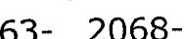
Backlog 2023- 2028- 2033- 2038- 2043- 2048- 2053- 2058- 2063- 2068- 2073- 2078- 2083-
2027 2032 2037 2042 2047 2052 2057 2062 2067 2072 2077 2082 2087

- Road Network
- Land Improvements
---- 5 Year Capital Requirement

-culverts
- Machinery & Equipment

-Buildings
-vehicles

Target Reinvestment Rate & Actual Reinvestment Rate

" 12.0%

10.0%
♦
♦
♦
♦
♦

8.0%

6.0%

4.0%

2.0%

Road Network Culverts Buildings Land Machinery &
Improvements Equipment
- Actual Reinvestment Rate • Target Reinvestment Rate
Vehicles

4
Analysis of T nk-funded
Assets
i
Key Insights

- Tax-funded assets are valued at $32t.

'"
million

- 95% of tax-funded assets are in fair or better condition

- The average annual capital requirernent to sustain the current level of service for tax-funded,,,assets is approximately $719,000 i,
.'I;

- Critical assets should be evaluated to determine appropriate risk mitigation activities and treatrrIent options

Road Network
The road network is a critical component of the provision of safe and efficient transportation services. It includes all municipally owned and maintained roadways and signs.

The Township's roads are maintained by the Public Works department who is also responsible for winter snow clearing, ice control, and dust control operations.

The state of the infrastructure for the road network is summarized in the following table.

Replacement Cost

Condition Financial Capacity

$30.1 million Good (69%) Annual Requirement:

$544,971

The following core values and level of service statements are a key driving force behind the Municipality's asset management planning:

Service Attribute
Level of Service Statement

Scope

Safe & Regulatory

Affordable Reliability
The road network service is conveniently accessible to the whole community in sufficient capacity (meets traffic demands) and is available under all most conditions.

The road network in good condition with regular inspection to minimize hazards and unplanned road closures.
The Annual Capital Reinvestment Rate of the road network is 0.3%.

The road network is overall in good condition and 100% of the road assets are in fair or better condition.

Asset Inventory & Replacement Cost
The table below includes the quantity, replacement cost method and total replacement cost of each asset segment in the Township's road network inventory.
'

 | Asset | Segment | Quantity | Primary Replacement  Cost Method | Total  Replacement Cost
 | LCB |  | 49 km | CPI Tables | $27,160,000
 | Gravel |  | 13 km | CPI Tables | $2,794,000
 | Signs |  | 91 | CPI Tables | $95,493
 |  | Total |  |  | $30,049,493

Total Current Replacement Cost: $30,049,493

LCB
I
$27.2m

Gravel $2.8m

Signs
$95k

I
$0 $Sm $10m $15m $20m $25m $30m Current Replacement Cost

Each asset's replacement cost should be reviewed periodically to determine whether adjustments are needed to more accurate represent realistic capital requirements.

Asset Condition
The table below identifies the current average condition and source of available condition data for each asset segment. The Average Condition (%) is a weighted value based on replacement cost.

Asset Segment Average Condition Average
(%) Condition Rating
LCB 66% Good
Condition Source
100% Assessed

Gravel |  | 68% | Good | 100% Assessed
Signs |  | 75% | Good | 100% Assessed
 | Average | 67% | Good | 100%  Assessed
The graph below visually illustrates the average condition for each asset segment on a very good to very poor scale.

- Very Good ■Good Fair Poor ■Very Poor

Signs

Gravel
!'. •
.' . ,:,;_ .:;••.. . •.
•'. .•

r • ' • • •'

$264k

I , "

LCB$
$2.6m

0% 25% 50% 75%
Value and Percentage of Assets by Replacement Cost

100%

To ensure that the Township's road network continues to provide an acceptable level of service, the Township should monitor the average condition of all assets. If the average condition declines, staff should re-evaluate their lifecycle management strategy to determine what combination of maintenance, rehabilitation, and replacement activities is required to increase the overall condition of the road network.

Current Approach to Condition Assessment (reviewed
Accurate and reliable condition data allows staff to more confidently determine the remaining service life of assets and identify the most cost-effective approach to managing assets. The following describes the Township's current approach:

- Road assessments are performed by in-house staff on an annual basis.
- Road patrols are performed by in-house staff several times a week.
- Road inspection results are recorded by road superintendent and associated minor defects are repaired by in-house staff immediately. Major defects are repaired for the approval from the councils.

    - Estimated Useful Life & Average Age
The Estimated Useful Life for road network assets has been assigned according to a combination of established industry standards and staff knowledge. The Average Age of each asset is based on the number of years each asset has been in-service. The Profile Lifecycle Estimated Useful Life and Weighted Average Age take the varying data in the segment into account and calculated by determining the weights by the replacement cost. The figure below represents the Estimated Useful Life and the Average Age for each segment, except when an asset has been assigned an assessed condition rating. Assessed condition may increase or decrease the
average service life remaining.

Asset Segment | Weighted Average Age (Years) | Profile Lifecycle  Estimated Useful Life (Years)
LCB | 12.3 | 20
Gravel Roads | 13.0 | 20
Signs | 13.0 | 50

      - Weighted Average Age □Weighted Average EUL
60
50
20
20
13.0
-
13.0
12.3
50
(/)
'-
-
C1l 40
Q)
>-
0
30
'-
Q)
.0
E 20
z:::i

10
0
LCB

Gravel

Signs

Each asset's Estimated Useful Life should be reviewed periodically to determine whether adjustments need to be made to better align with the observed length of service life for each asset type.

Lifecycle Management Strategy
The condition or performance of most assets will deteriorate over time. This process is affected by a range of factors including an asset's characteristics, location, utilization, maintenance history and environment.

The following lifecycle strategies have been developed as a proactive approach to managing the lifecycle of LCB roads and Gravel Roads. Instead of allowing the roads to deteriorate until replacement is required, strategic rehabilitation is expected to extend the service life of roads at a lower total cost.

LCB Roads

Event Name Event Class Event Trigger

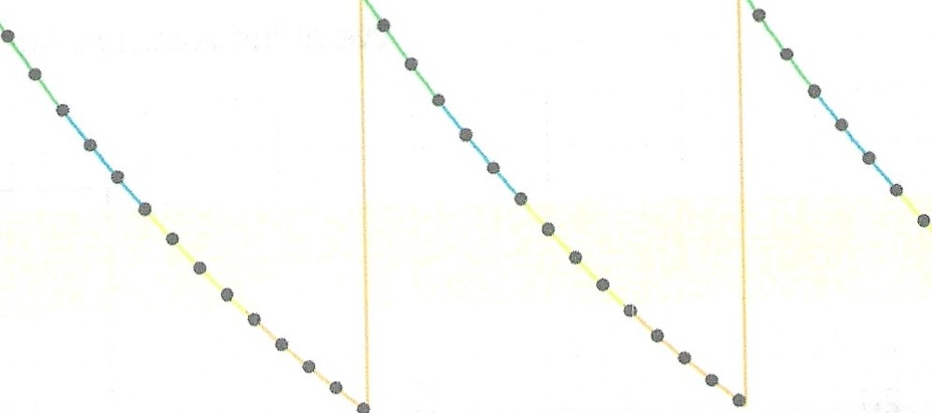
Patching Resurfacing Reconstruction
•
•
MaintenancE Rehabilitation Replacement
Repeat annually
1 Condition, repeat 3 times O Condition

4.0

3.5

3.0

,_,
1.5
• •
• • •
• • •
• •
• • •
•
•

Gravel Roads

Event Name Event Class Event Trigger

Grading

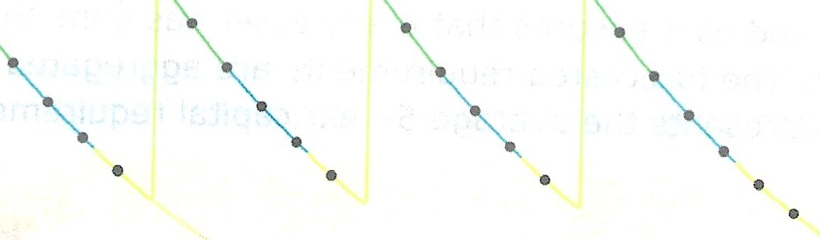
Gravelling - Adding Material Reconstruction
Maintenance
Preventative Maintenance
Replacement
Repeat annually Repeat every 6 years 3 times
0 Condition

Or, ti
P lt.d
4.0
,.,
i ,3,.0
,.,
• • •
• •
Tim,(inVor J

Forecasted Capital Requirements
Based on the lifecycle strategies identified previously for Surface Treated and Gravel roads, and assuming the end-of-life replacement of all other assets in this category, the following graph forecasts capital requirements for the road network.

The following graph forecasts long-term capital requirements. The annual capital requirement represents the average amount per year that the Township should allocate towards funding rehabilitation and replacement needs. The following graph identifies capital requirements from 2022 to 2087. The annual capital requirement is $544,971. This projection is used as it ensures that every asset has gone through one full iteration of replacement. The forecasted requirements are aggregated into 5-year bins and the trend line represents the average 5-year capital requirements.

Vl C

Q)
u
"E.
&

$24m

$21m

$18m

$15m
$25.0m

:§ $12m
·o.
IO

$9m

B $6m
(r_
$3m

$3.4m

· 7 5

$ QJ"Il.-

$616k

$0 $0 $357k $336k $34k $16k $67k $ 0
k $16k $0

$0
 | Backlog 2023- 2028- 2033- 2038- | 2043- | 2048- | 2053- | 2058- 2063- 2068- 2073- 2078- 2083-
 | 2027 2032 2037 2042 | 2047 | 2052 | 2057 | 2062 2067 2072 2077 2082 2087

- LCB -Gravel -Signs --··- 5 Year Capital Requirement

The projected cost of lifecycle activities that will need to be undertaken over the next 10 years to maintain the current level of service can be found in Appendix A.

    - Risk & Criticality
Risk Matrix
The following risk matrix provides a visual representation of the relationship between the probability of failure and the consequence of failure for the assets within this asset category based on 2022 inventory data. See Appendix C for the criteria used to determine the risk rating of each asset.
OAssets

$0.00
2 Assets
22.40 km
$2,361,980.00
O Assets
O Assets
o Assets
$0,00
$0.00
$0.00
0 Assets
4 Assets
17.10 km
$1,392,471.00
1 Asset
2.30 km
$207,020.00
O Assets
O Assets
$0.00
$0.00
$0.00
1 Asset
0.90 km
$59,466.00
4Assets
96.60 km, unit(s)
$288,332.00
1 Asset 1.90km
$79,006.00
O Assets
o Assets
$0.00
$0.00
O Assets
o Assets
o Assets
$0.00
5 Assets 8.10km
$167,992.00
2 Assets
1.70 km
$79,477.00
$0.00
$0.00
1 Asset 0.20km
$6,058.90
2 Assets 1.00km
$11,160.00
o Assets
O Assets
0 Assets
$0.00
$0.00
$0.00

5

4

a}
3
V,
C
0u

2

2 3 4 5

Probabrlity
This is a high-level model developed for the purposes of this AMP and Township staff should review and adjust the risk model to reflect an evolving understanding of both the probability and consequences of asset failure.

The asset-specific attributes that municipal staff utilize to define and prioritize the criticality of the road network are documented below:

Probability of Failure {POF) Consequence of Failure (COF)

Condition Replacement Cost (Economic)

The identification of critical assets allows the Township to determine appropriate risk mitigation strategies and treatment options. Risk mitigation may include asset­ specific lifecycle strategies, condition assessment strategies, or simply the need to collect better asset data.

....,

Risks to Current Asset Management Strategies
The following section summarizes key trends, challenges, and risks to service delivery that the Township is currently facing:

Climate Change & Extreme Events
The trend of climate change-induced extreme precipitation events is projected to continue. Severe rainfall can impact service availability and cause flooding. Flooding can damaqe paved surface and washout the gravel. As a result, higher maintenance and rehabilitation requirements are expected to maintain the same level of service, to avoid complaints, liabilities, and larger capital spending. To improve asset resiliency, staff should identify the critical areas and improve drainage through enhanced lifecycle strategies.

Capital Funding Strategies
Major capital rehabilitation projects for roads are dependant on the availability of grant funding opportunities. When grants are not available, roadway projects may be deferred. Currently, major lifecycle projects are presented to the councils for approval on an as needed basis. The Township can consider develop an annual capital funding strategy by utilizing the roadway condition from regular road patrols.
The annual capital funding strategy could reduce dependency on grant funding and help prevent deferral of capital works.

    - Levels of Service
The following tables identify the Township's current level of service for the road network. These metrics include the technical and community level of service metrics that are required as part of 0. Reg. 588/17 as well as any additional performance measures that the Township has selected for this AMP.

Community Levels of Service
The following table outlines the qualitative descriptions that determine the community levels of service provided by the road network.

Service Attribute

Scope

Quality
Qualitative Description
Description, which may include maps, of the road network in the municipality and its level of connectivity

Description or images that illustrate the different levels of road class pavement and sidewalk condition
Current LOS (2021}

See Appendix B

Very Poor: Widespread signs of deterioration. Requires remedial work to bring road up to standard. Service is affected severely. (0-20% life remaining) Poor: Large portions of road exhibiting deterioration. Road is mostly below standard. (20-40% life remaining)
Fair: Some sections of road starting to deteriorate. Requires some remedial work and surface upgrade in near future. (40- 60% life remaining)
Good: Road is in overall good condition. Few sections are starting to show signs of minimal deterioration. (60-80% life remaining)
Very Good: Surface was newly or recently upgraded. No signs of deterioration or remedial work required. (80-100% life remaining)

Technical Levels of Service
The following table outlines the quantitative metrics that determine the technical level of service provided by the road network.

Service Technical Metric Current LOS Attribute (2021)
0
Lane-km of arterial roads (MMS classes 1 and 2) per land area (km/km2)
Accessible & Lane-km of collector roads (MMS classes 3 and 4) Reliable per land area (km/km2)
0
Lane-km of local roads (MMS classes 5 and 6) per 0.56
2
land area (km/km )
Average pavement condition index for paved N/A roads in the municipality
Average surface condition for surface treated 66% roads in the municipality
Quality
Average surface condition for unpaved roads in 68% the municipality

Recommendations
Asset Inventory
- Street signs are pooled under a single asset record that should be broken into discrete segments to allow for detailed planning and analysis.
Replacement Costs
- A number of replacement costs for road assets were based on the inflation of historical costs. These costs should be evaluated to determine their accuracy and reliability. Going forward, the Township may consider using insurance records or third-party assessments to better account for the true building replacement cost.
Condition Assessment Strategies
- The Township should continue or expand the regular condition assessments for culvert to better inform short and long-term capital requirements.
Risk Management Strategies
- Implement risk-based decision-making as part of asset management planning and budgeting processes. This should include the regular review of high-risk assets to determine appropriate risk mitigation strategies.
- Review risk models on a regular basis and adjust according to an evolving understanding of the probability and consequences of asset failure.
Levels of Service
- Continue to measure current levels of service in accordance with the metrics identified in 0. Reg. 588/17 and those metrics that the Township believes to provide meaningful and reliable inputs into asset management planning.
- Work towards identifying proposed levels of service as per 0. Reg. 588/17 and identify the strategies that are required to close any gaps between current and proposed levels of service.

Culverts
The Township does not own any bridges or culverts with span more than 3 meters. The assets in this category are the drainage culverts with span less than 3 meters. Staff are working towards improving the accuracy and reliability of their drainage culverts to assist with long-term asset management planning.

The state of the infrastructure for the drainage culverts is summarized in the following table.

Replacement Cost

Condition Financial Capacity

$170,500 Good (65%) Annual Requirement:

$ 4,547

The following core values and level of service statements are a key driving force behind the Municipality's asset management planning:

Service Attribute

Scope

Safe & Regulatory

Reliability
Level of Service Statement

Drainage culverts are constructed to convey water, avoid severe flooding which can reduce the deterioration caused by flooding.

Regular inspection of draina Je culverts is in place to maintain current drainage capacity and load restrictions are applied on roads in Spring to reduce damages caused by heavy traffic.
The drainage culverts are overall in fair condition.

Asset Inventory & Replacement Cost
The table below includes the quantity, replacement cost method and total replacement cost of each asset segment in the Township's drainage culverts inventory.

Asset Segment Quantity Primary Replacement
Cost Method
Total Replacement Cost

Drainage Culverts | 179 | User-Defined Costs | $170,500
Total |  |  | $170,500

Total Current Replacement Cost: $170,500

Drainage Culverts lr ­
$170k

$0 $50k $100k $150k $200k Current Replacement Cost
Each asset's replacement cost should be reviewed periodically to determine whether adjustments are needed to more accurate represent realistic capital requirements.

    - Asset Condition
The table below identifies the current average condition and source of available condition data for each asset segment. The Average Condition (%) is a weighted value based on replacement cost.

Asset Segment
Average Average
Condition

Condition (%) C-o-ndition Rating
Source

Drainage Culvert
65% Good
100% Assessed

Average 65% Gc>od 100% Assessed

The graph below visually illustrates the average condition for each asset segment on a very good to very poor scale.

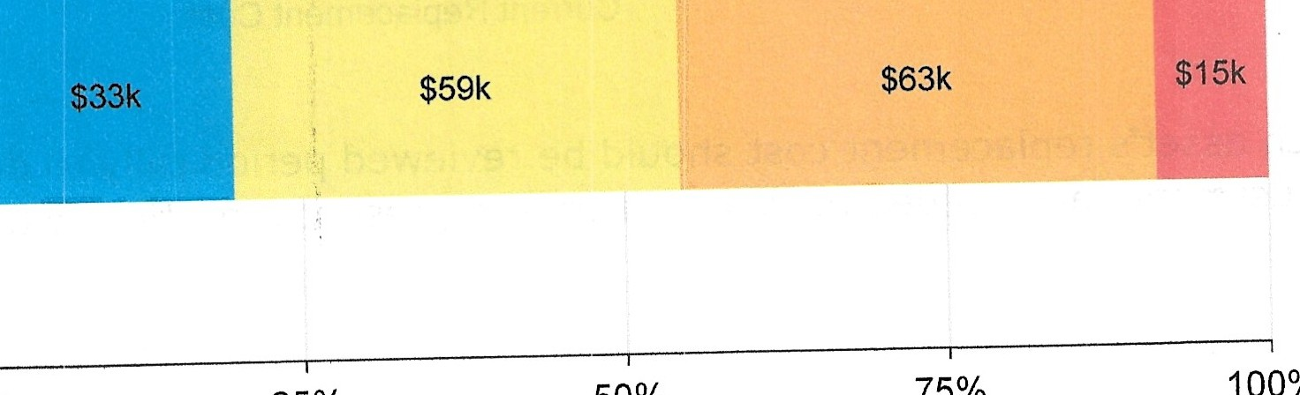
- Very Good II Good Fair ■ Poor ■Very Poor

Drainage Culverts

0% 25% 50% 75% 100%

Value and Percentage of Assets by Replacement Cost

To ensure that the Township's continues to provide an acceptable level of service, the Township should monitor the average condition of all assets. If the average condition declines, staff should re-evaluate their lifecycle management strategy to determine what combination of maintenance, rehabilitation, and replacement activities is required to increase the overall condition of the drainage culverts.

Current Approach to Condition Assessment
Accurate and reliable condition data allows staff to more confidently determine the remaining service life of assets and identify the most cost-effective approach to managing assets. The following describes the Township's current approach:
- Visual Inspection of drainage culverts are performed weekly by municipal staff.
- Inspection results are recorded by road superintendent.

Estimated Useful Life & Average Age
The Estimated Useful Life for culverts has been assigned according to a combination of established industry standards and staff knowledge. The Average Age of each asset is based on the number of years each asset has been in-service. The Profile Lifecycle Estimated Useful Life and weighted Average Age take the varying data in the segment into account and calculated by determining the weights by the replacement cost. The figure below represents the Estimated Useful Life and the Average Age for each segment, except when an asset has been assigned an assessed condition rating. Assessed condition may increase or decrease the
average service life remaining.

Asset Segment

Weighted Average Age (Years)
Profile Lifecycle Estimated Useful Life (Years)

Drainage Culverts 13.0 38

40
- Weighted Average Age □Weighted Average EUL
38
13.0
35
.(./)..
30
ro
>-
Q)
25
4-
⁰....
20
Q)
..0
E 15
::I
z
10
5
0
Drainage Culverts
Each asset's Estimated Useful Life should be reviewed periodically to determine whether adjustments need to be made to better align with the observed length of service life for each asset type.

Lifecycle Management Strategy
The condition or performance of most assets will deteriorate over time. To ensure that municipal assets are performing as expected and meeting the needs of customers, it is important to establish a lifecycle management strategy to proactively manage asset deterioration.

The following table outlines the Township's current lifecycle management strategy.

Activity Type Description of Current Strategy

Maintenance, Rehabilitation and Replacement
Visual inspections are performed by municipal staff on an weekly basis to identify rust, cracks or existence of obstruction.

Maintenance and cleaning are completed yearly to remove obstruction, maintain efficient drainage, and avoid flooding.
Full replacement is undertaken when break or rust are identified during inspection.

Forecasted Capital Requirements
The following graph forecasts long-term capital requirements. The annual capital requirement represents the average amount per year that the Township should allocate towards funding rehabilitation and replacement needs. The following graph identifies capital requirements from 2022 to 2072 and the Annual Capital Requirement is $4,547. This projection is used as it ensures that every asset has gone through one full iteration of replacement. The forecasted requirements are aggregated into 5-year bins and the trend line represents the average 5-year capital requirements.

(fJ
$?Ok  $60k  $50k  $40k  $30k  $20k | $63k  $59k  $33k  $15k $15k
$10k
 | $0 $0 |  | $0 |  | $0 |  | $0 |  | $0
$0
 | Backlog 2023- | 2028- | 2033- | 2038- | 2043- | 2048- | 2053- | 2058- | 2063- | 2068-
 | 2027 | 2032 | 2037 | 2042 | 2047 | 2052 | 2057 | 2062 | 2067 | 2072

+-'
C
Q)
E
Q)
(.)
aro.
a::
Q)
·a.
ro
()
tl
Q)
+-'
(fJ
ro
(.)
.Q..).
0
LL

- Drainage Culverts 5 Year Capital Requirement

The projected cost of lifecycle activities that will need to be undertaken over the next 10 years to maintain the current level of service can be found in Appendix A.

