Burpee and Mills Newsletter March 2023

Family Fun Day was a huge success!! There was a fantastic turnout. Thanks to all the community members that attended and all the people that donated chili, baking, and their time. Special thanks to Nikki Middleton and Rick Graham for organizing and all their hard work.
Join us for our next Community event, March Break Potluck and Family Dance. March 17 from 6:00pm-10:00pm.
The Snow Sculpture Contest will be extended until March 17, and judging will occur at the dance. Please email pictures of your creations to burpeemills@vianet.ca by Wednesday March 15. Prizes for 1st, 2nd, and 3rd best sculptures!
Don't forget about the Volunteer Fair!! Our fire department will be there recruiting. Gordon Community Centre April 12, 2:00pm-8:00pm.
Join us for Monday night euchre. 7:00pm at the community centre. $5 entry. There will be cash prizes for the winners as well as door prizes, and an abundance of fun.
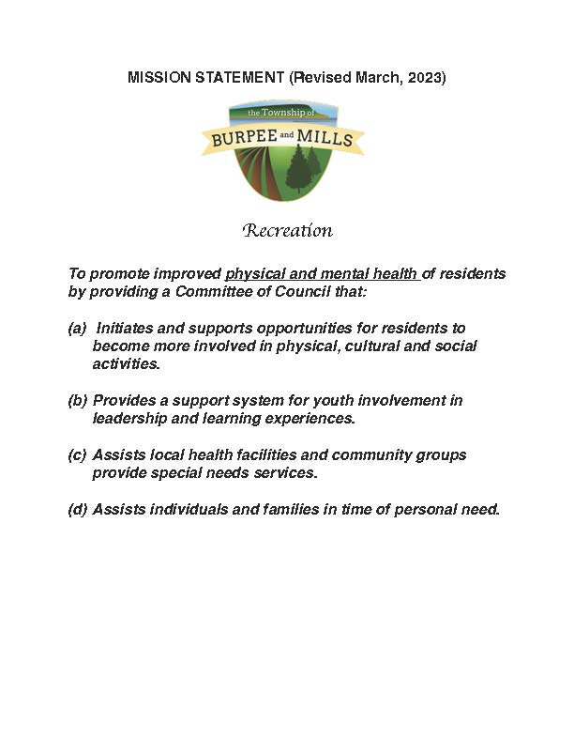
The Recreation Committee has successfully absorbed the Golden Age Club. A new mission statement has been adopted. The committee will meet March 28 at 7:00pm to elect a new executive. Plans and ideas for the coming year will be brought forward and discussed. Everybody is welcome at the meeting and volunteers will be especially welcome.
The Township is in need of some volunteers that are certified food handlers. Recurring events that wish to serve food must have at least one person present that has the certification. There is a course coming up March 20 in NEMI. If you're interested, or for more details, contact the township office.
GG'S Diner is looking for help for the summer. They would like to hire kitchen help, as well as two people to wait tables and a dishwasher. For more information, please email ggs.manitoulin@gmail.com
The Gym continues to operate during regular business hours from Monday to Thursday. It is still open in the evenings on Tuesday and Thursday only, 7:00pm-9:00pm.
Next Council Meeting is April 4 at 7:00pm
If you'd prefer the newsletter emailed to you, please contact Lynn at the township office. Also, if you've had issues not receiving the printed version, let her know so we can rectify the situation.
Smoking in Bed is a leading cause of fire deaths. Be sure it's out before you say goodnight.
