BURPEE & MILLS NEWSLETTER
January 2023

Council Report:
The next regular meeting of municipal council will be held Tuesday, February 7th at 7:00 p.m.

Fitness Centre Report:
Now is a good time to get in shape. Residents of our municipality, as well as non-residents, are encouraged to join the Fitness Centre. The gym is equipped with a variety of cardio equipment for your workout enjoyment including treadmills, elliptical equipment and exercise bikes.
Monthly fees are $15 for students under 18, $15 for seniors 60 and over, $20 for residents and $25 for non-residents. Visitors may use the gym for $5 a day or $15 for one week. The gym is open Monday through Thursday during regular office hours. Gym rules require two persons to be present when working out. The Fitness Centre is supervised by volunteers in the evenings on Tuesdays and Thursdays from 7:00 p.m. – 9:00 p.m.

Gym supervision is provided by volunteers. Fees cover the cost of inspection, maintenance and replacement of gym equipment. Tammi Middleton is the Gym Committee contact at 705-282-7465.
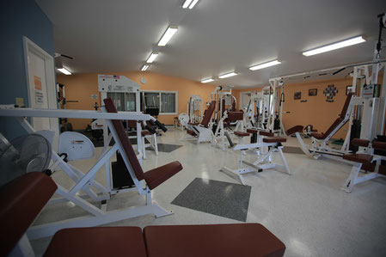
Municipal Snow Removal:
Residents are requested NOT to push any snow from their driveways onto municipal roadways. These snow banks may freeze and create a serious hazard to the municipal snow plow and any other vehicles when they hit these obstructions. Residents are also reminded not to park vehicles on the road allowance that could hinder the snow plow.

Fire Team Report:
Firefighters who are no longer active are requested to return fire team equipment such as radios, helmets, jackets and boots as soon as possible.

