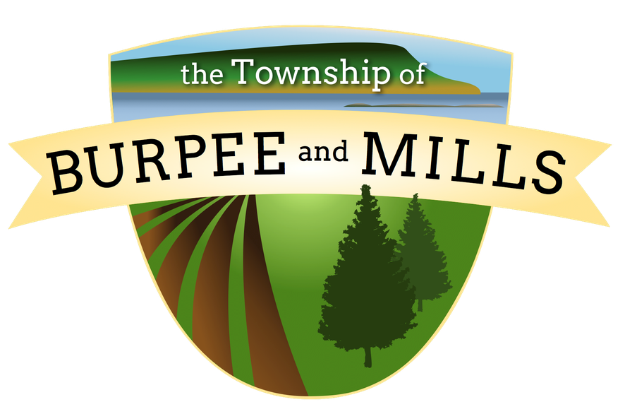

The Corporation of the Township of Burpee and Mills
2022 Municipal Election Accessibility Plan

Purpose
To prepare a plan that will identify and eliminate barriers for persons with disabilities to ensure that election services are accessible to all electors and candidates.
Preamble
The Municipal Elections Act states that the clerk who is responsible for conducting an election shall have regard to the needs of electors and candidates with disabilities. The Clerk is also required to prepare a plan regarding the identification, removal and prevention of barriers that affect electors and candidates with disabilities and shall make the plan available to the public before voting day in a regular election.
Plan Objectives
To ensure that:
(1) persons with disabilities can independently cast their vote.
(2) persons with disabilities have full and equal access to all election information that is made publicly available by the Township.
(3) persons with disabilities have full and equal access to Township facilities made available to the public for the purpose of conducting the election.

Plan
In-Person Voting with Paper Ballots:
The Township will be using a paper ballot where on which electors choose their preferred candidate(s) by placing a mark, with a pen or pencil in the circle next to the name of the chosen candidate(s). An elector with a disability may choose to have a person assist them behind the voting privacy screen. If an elector does not have a support person, trained Election Officials will be present at the Township of Burpee and Mills voting location to provide assistance. Magnifying sheets will be provided behind each privacy voting screen for use by electors in reading the ballot. The voting areas at each location will be set up taking into consideration the table heights and to ensure proper spacing between each area, allowing for wider aisle widths for use of a wheelchair or any other mobility device. Having accessible voting areas will allow electors, if they wish, to vote independently without the assistance of a support person.
Accessible Route to Entrance and Exit:
The route to the entrance of the voting location shall be unobstructed and accessible. The route shall be wide enough to allow for an individual using a wheelchair, mobile equipment, other assistive device, or service animal to travel safely. An easily navigable route will be marked for entry into the voting location and into the voting area within the location. The voting area will be identified with clear and understandable signage. Doors into the Voter Help Centre(s) shall be accessible and easy to open or shall remain propped open for the duration of the voting location hours. Routine checks of entrance and exit routes will be made throughout the hours of operation.
Parking:
Accessible parking shall be available at all voting locations. The designated parking space(s) shall be clearly marked with the International Accessibility Symbol and will be on firm and level ground, close to the entrance of the voting location. Routine checks will be made to ensure all entrances remain barrier free through the course of the day.
Interior Voting Area:
Access to the interior Voting Area will be level and easily traversed. Any doormats or carpeting will be level with the floor to prevent potential tripping hazards. All voting areas are to be well lit and seating will be made available
Voting Assistance Support Person/Friend of the Voter:
People with disabilities shall be permitted to be accompanied by a support person at any voting location. A designated support person and/or ‘Friend of the Voter’ will be administered an oath of secrecy/confidentiality by an Election Official prior to providing any such assistance.
Service Animals:
Pursuant to the Township of Burpee and Mills Accessible Customer Service Policy, individuals requiring service animals are permitted to be accompanied by a service animal at all voting locations.
Election Officials:
At voting locations, upon request, Election Officials are available to assist any voter who requires assistance in casting their traditional paper ballot. All individuals working in the capacity of an Election Official are formally appointed as such and administered an oath of secrecy prior to voting day. Prior to entering the voting booth, the Election Official shall, in conjunction with the elector, determine the extent to which he/she needs assistance and the best way in which this assistance can be provided. This may actually be marking the ballot as directed by the person with the disability. Assistive Personal Equipment Electors with disabilities may use assistive personal devices including wheelchairs, walkers, white canes, walking canes, note taking devices, portable magnifiers, recording machines, assistive listening devices, personal oxygen tanks and devices for grasping at the voting location.
Vision Loss:
Each Voting Place will be equipped with magnifying sheets to assist an individual with low vision.

