BURPEE & MILLS NEWSLETTER
January 2022
Council Report:
The next regular meeting of municipal council will be held Wednesday, January 5th at 7:30 p.m.
The Burpee & Mills Township office is open to the public. During regular business hours please press the intercom button or call 705-282-0624 for assistance. The office is open Monday to Thursday from 8:30 a.m. to 4:00 p.m. and is closed from 12:00 – 12:30 p.m. for lunch.
The gym, hall and public washrooms remain closed.

Municipal Snow Removal:
Residents are requested NOT to push any snow from their driveways onto municipal roadways. These snow banks may freeze and create a serious hazard to the municipal snow plow and any other vehicles when they hit these obstructions. Residents are also reminded not to park vehicles on the road allowance that could hinder the snow plow.

Fire Team Report:
Keep fire safety in mind as temperatures drop!
We often see more home fires during the winter months due to heating equipment and appliances. People need to pay close attention to potential fire hazards such as fireplaces, furnaces, chimneys and vents, and space heaters.

There are some simple things people can do to stay fire safe during the colder months:
- Have all fuel-burning appliances inspected annually by a registered fuel contractor.
- Keep chimneys and intake/exhaust vents for furnaces and heating appliances free of debris, ice and snow accumulations to reduce the risk of carbon monoxide (CO) build-up from inefficient combustion.
- Burn dry, well-seasoned wood in fireplaces and woodstoves to reduce the risk of excessive creosote build-up in chimneys.
- Allow ashes from your fireplace or woodstove to cool before emptying them into a metal container with a tight-fitting lid. Keep the container outside.
- Keep space heaters at least one metre (3 feet) away from anything that can burn, including curtains, upholstery and clothing.
- Replace worn or damaged electrical wires and connections on vehicles and extension cords and use the proper gauge extension cord for vehicle block heaters.
- Consider using approved timers for vehicle block heaters rather than leaving heaters on all night.
- Ensure that vehicles are not left running inside any garage or building.
- Ensure there is a working smoke alarm on every storey and outside all sleeping areas of your home.
- Install CO alarms to alert you to the presence of this deadly gas.
Community Safety:
Residents are reminded that incidents of break, entry and theft, especially at night, continue in our community. Be sure that items such as gasoline and diesel fuel are secured and out of reach. Please watch for suspicious activity in your neighbourhood and if you notice an unwelcome intruder on your property, do not hesitate to call 911 to alert the OPP.

Job Opportunity:
The position of Transfer Station Attendant is now open. Applicants may submit their resume to the municipal office by email to burpeemills@vianet.ca by Tuesday, February 15th.

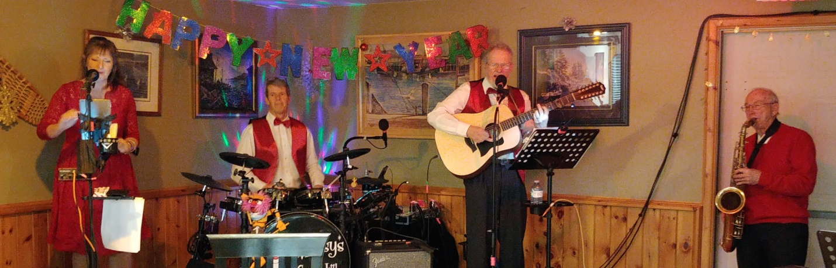

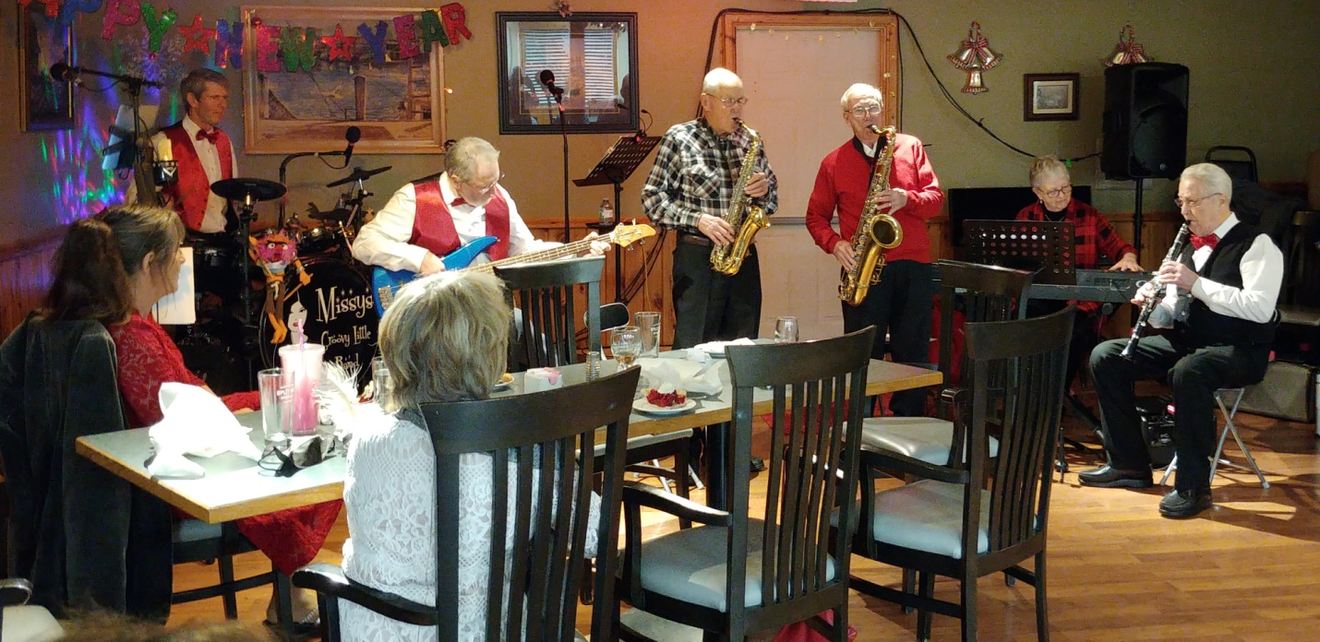

The Manitoulin Swing Band and Missy’s Groovy Little Band at GG’s on New Year’s Eve.

