BURPEE & MILLS NEWSLETTER
.
December 2021

Council Report:
The next regular meeting of municipal council will be held Wednesday, January 5th at 7:30 p.m.
The Burpee & Mills Township office is open to the public. During regular business hours please press the intercom button or call 705-282-0624 for assistance. The office is open Monday to Thursday from 8:30 a.m. to 4:00 p.m. and is closed from 12:00 – 12:30 p.m. for lunch.
The gym, hall and public washrooms remain closed.

The municipal office will be closed Friday, December 24th until Tuesday, January 4th for the Christmas season.

Municipal Snow Removal:
Residents are requested NOT to push any snow from their driveways onto municipal roadways. These snow banks may freeze and create a serious hazard to the municipal snow plow and any other vehicles when they hit these obstructions. Residents are also reminded not to park vehicles on the road allowance that could hinder the snow plow.

Holiday Fire Safety Checklist:

- Buy a fresh tree and keep the base of the trunk in water at all times.
- Lit candles should never be placed on or near the Christmas tree.
- Check all sets of lights before putting them on the tree. Discard any sets that are damaged or old.
- Stay in the kitchen when cooking. Unattended cooking is the leading cause of kitchen fires.
- Keep candles in a sturdy holder away from children, pets and combustible materials. Blow them out before leaving the room.
- Alcohol and fire are a dangerous mix. Keep a close eye on anyone attempting to cook or smoke while under the influence of alcohol.
- Encourage smokers to smoke outside. Check for cigarette butts between sofa and chair cushions before going to bed.
- Install smoke alarms on every storey and outside sleeping areas. Carbon monoxide alarms must also be installed outside all sleeping areas if your home has a fuel-burning appliance, fireplace or attached garage. Test the alarms monthly and change batteries at least once a year.

Community Safety:
Incidents of break, entry and theft, especially at night, continue in our community. Most recently there have been thefts of gasoline and diesel fuel. Be sure that such items are secured and out of reach for these criminals. Please watch for suspicious activity in your neighbourhood and if you notice an unwelcome intruder on your property, do not hesitate to call 911 to alert the OPP.

History Books:
Are you looking for Christmas gift ideas? Pat Best’s books History of Burpee Township and History of Mills Township are available at the municipal office for $20.00 each.

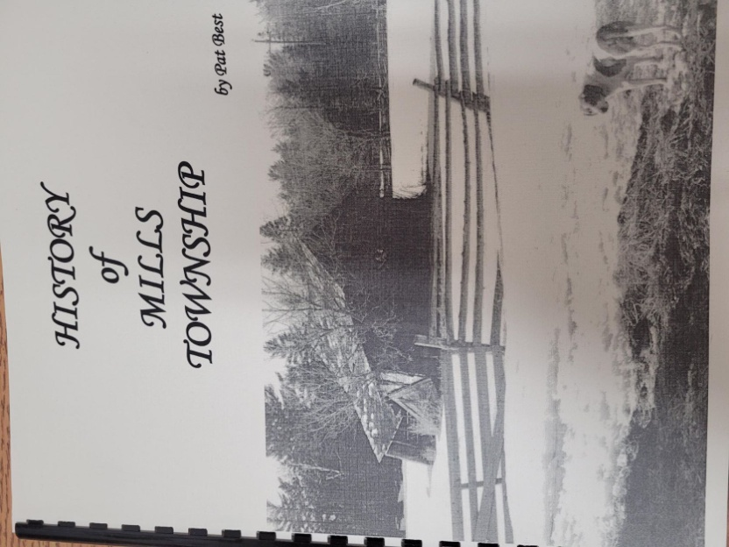
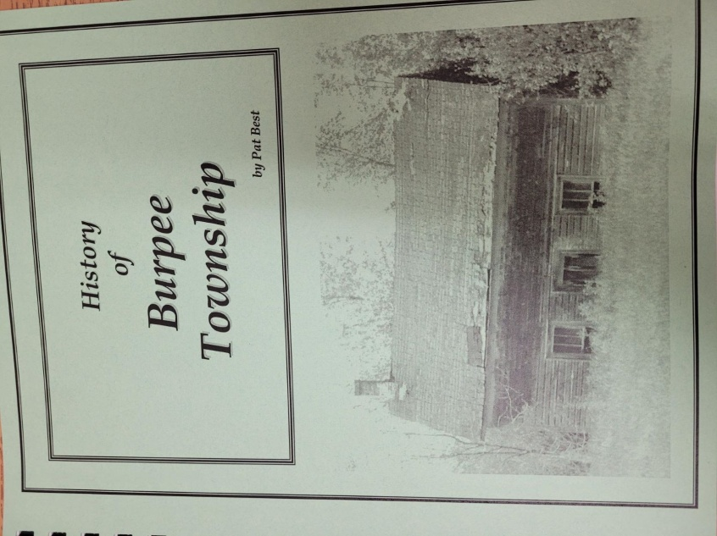

Season’s Greetings

