BURPEE & MILLS NEWSLETTER
.
October 2021
Council Report:
The next regular meeting of municipal council will be held on Tuesday, November 2nd at 7:30 p.m.
The Burpee & Mills Township office is open to the public. During regular business hours please press the intercom button or call 705-282-0624 for assistance. The office is open Monday to Thursday from 8:30 a.m. to 4:00 p.m. and is closed from 12:00 – 12:30 p.m. for lunch.
The gym, hall and public washrooms remain closed.
Burpee & Mills Cemetery Board Report:
This beautiful autumn weather will welcome many family gatherings for one last yearly visit to our cemetery, especially during the Thanksgiving Weekend. Perhaps this would be an ideal time to remove your floral decorations from monuments and grave sites to prevent weather damage. Help us to keep our cemetery grounds as attractive as possible.
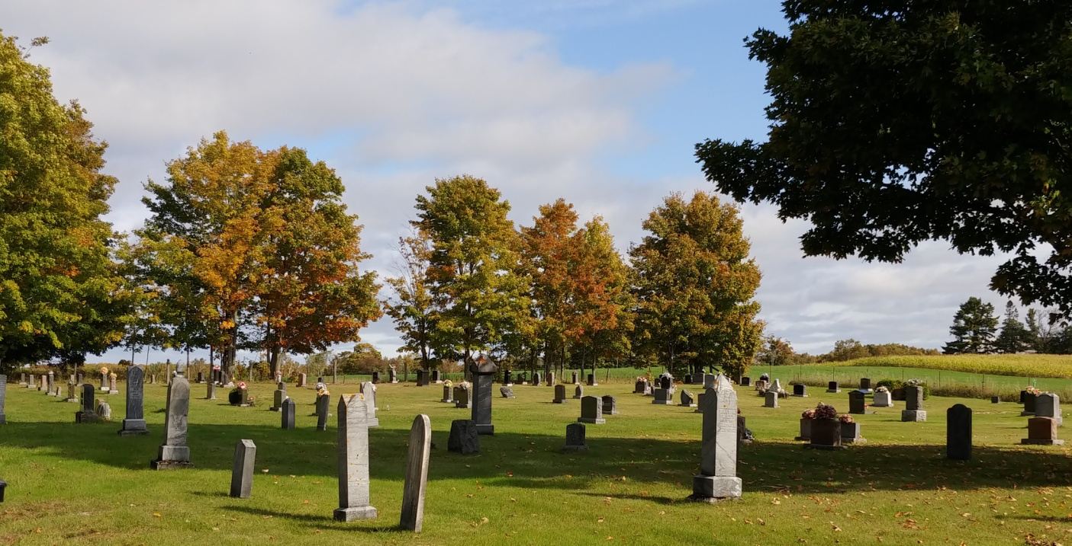
We take this opportunity to thank Shane and Mike for their caring maintenance of the cemetery grounds as well as special consideration given to grieving family members during interment of loved ones.

Community Safety:
Recently we have had reports of trespassing on private property, especially at night, as well as two cases of break, entry and theft. Please watch for suspicious activity in your neighbourhood and if you notice an unwelcome intruder on your property, do not hesitate to call 911 to alert the OPP.

Fire Team Report:
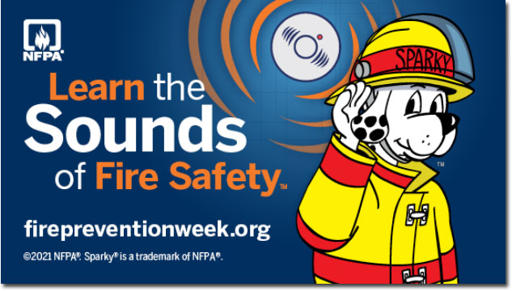
Fire Prevention Week runs from October 3-9. Everyone is encouraged to test their smoke and carbon monoxide alarms and “Get Loud” and “Learn the Sounds of Fire Safety.” By law, every home in Ontario must have a working smoke alarm on every storey and outside all sleeping areas however, too often fatal fires in Ontario occur in homes where there were no working smoke alarms. Do you know what your smoke alarm is telling you with those beeps? “Get Loud!” and push the test button on smoke and carbon monoxide alarms every month to learn the sound alarms make. Testing alarms produces a beep, the sound of alarms in an emergency. Replace the batteries if the alarms do not sound when the test button is pushed. If the alarms still don’t sound, replace the alarms. Testing your alarms is the only way to ensure they are working and that you and your family can be alerted in the event of a fire. Knowing the different sounds your smoke and carbon monoxide alarms make can save you, your loved ones, and your home. Get Loud! by testing your alarms every month to learn the sound they make and to ensure the batteries work.

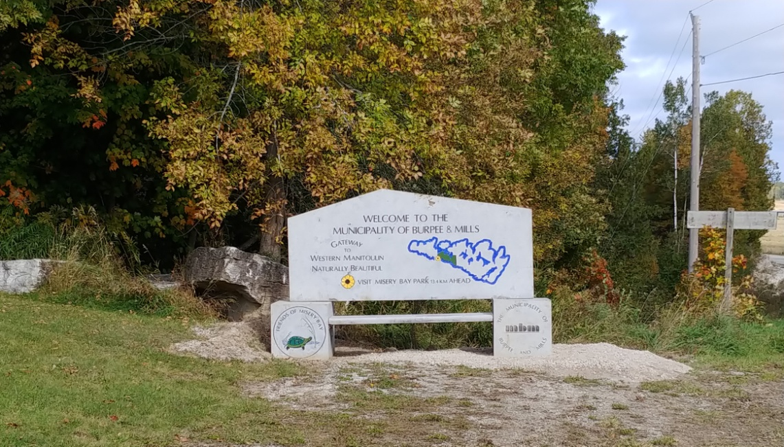

The Municipality of Burpee and Mills Welcome Monument has a new home at the complex

