BURPEE & MILLS NEWSLETTER
.
September 2021
Council Report:
The next meeting of municipal council will be held on Tuesday, October 5th at 7:30 p.m.
The Burpee & Mills Township office is open to the public. During regular business hours please press the intercom button or call 705-282-0624 for assistance. The gym, hall and public washrooms remain closed.
New Office Hours:
The municipal office has changed the office hours to be more in line with other municipal offices on Manitoulin Island. The office will now be open Monday to Thursday from 8:30 a.m. to 4:00 p.m. and will be closed from 12:00 – 12:30 p.m. for lunch
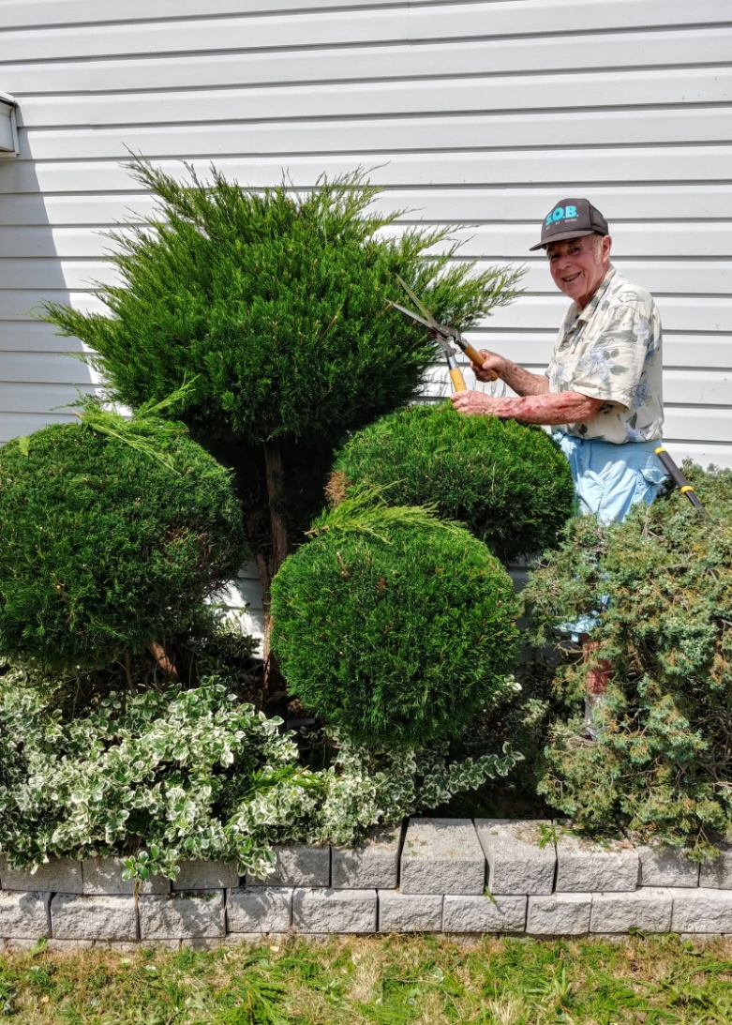
Garden Club Report:
The Garden Club had another work bee to clean up and weed the gardens at the community centre. Many thanks to Tom Prior for giving one of the shrubs at the entrance a much needed trim. If you are interested in volunteering to work on the community garden, please call Seija Bailey at 705-282-8108.

Fire Team Report:
Now is a good time to make sure you are ready for the cool weather. Clean your chimneys; clean and inspect your stovepipes; and also take a good look at your furnace or stove. If you cannot do it yourself, get someone to do it for you. This is very important to make sure that everything is in good working order. Please use common sense when burning, so that our volunteer firefighters are not called out to situations that could have been prevented.
Fire Prevention week is just around the corner: October 3-9, 2021. This year’s theme is “Learn the Sounds of Fire Safety.”

Transfer Station Report:
Special procedures remain in place at the Transfer Station in order to practise physical distancing. Remain in your vehicle and wait for an attendant to direct you, one person at a time.
Please sort your materials before you come to the transfer station. If you bring materials to the transfer station in bags, the bags need to be CLEAR. Please wear a mask.
Hours of Operation:
- Saturday – 10:30 a.m. to 12:00
- Tuesday – 2 p.m. to 3 p.m. (Summer only - 1st week of June to last week in August)
- Thursday – 7 p.m. to 8 p.m.

