BURPEE & MILLS NEWSLETTER
July 2021
Council Report:
The next meeting of municipal council will be held on Tuesday, August 3rd at 7:30 p.m.
The Burpee & Mills Township office is open to the public. During regular business hours please press the intercom button or call 705-282-0624 for assistance. The gym, hall and public washrooms remain closed.

Fire Team Report:

Cottage Fire Safety – Tip Sheet
Install smoke alarms on every storey and outside all sleeping areas. It’s the law for all Ontario homes, cottages, cabins and seasonal homes to have working smoke alarms on every storey and outside all sleeping areas.
- Test smoke alarms at least monthly or each time you return to the cottage. Pack a new smoke alarm and extra smoke alarm batteries in case they need replacement.
- Install and ensure carbon monoxide alarms in your cottage if it has a fuel-burning appliance.
- Develop and practice a home fire escape plan to ensure everyone knows what to do if the smoke alarm sounds.
- Call 911 in case of fire and be sure to know your cottage’s civic number in case of emergency.
- Clean barbecues before using them. Keep an eye on lit barbecues and ensure all combustibles, as well as children and pets are kept well away from them. Fires can happen when barbecues are left unattended.
- Keep barbecue lighters and matches out of sight and reach of children.
- Remember to bring a flashlight with extra batteries.
- Check heating appliances and chimneys before using them.
- Check with your municipality, or Ministry of Natural Resources to determine whether open air burning is permitted before having a campfire or burning brush. If open burning is allowed, fires should be built on bare soil or on exposed rock. Remove leaves and twigs from around the fire to keep it from spreading. Always keep a bucket of water, sand, or even a shovel close by and supervise the fire at all times.
- If you must smoke, do so outside. Keep a large can with water nearby so cigarette butts can be safely discarded. If you drink, do so responsibly. Tobacco use and excessive alcohol consumption are contributing factors in many fires and can lead to serious injuries.
- Burn candles in sturdy candleholders that will not tip and are covered with a glass shade. When you go out blow out!!
THE FIRE BAN HAS BEEN LIFTED FOR THE TOWNSHIP OF BURPEE & MILLS.

Check the website www.burpeemills.com for up to date information regarding fire bans.

Job Opportunity:
The Township of Burpee and Mills has a job opportunity for a By-law Enforcement Officer. The position is part-time (approximately 20 hours per week). The By-law Enforcement Officer is responsible for conducting investigations into alleged violations of the Municipality’s by-laws, follow-up with negotiation and education and enforcement of those by-laws.
Please see the website www.burpeemills.com for a copy of the job description. Deadline for submissions is Thursday, July 22, 2021. Phone & Fax 705-282-0624. Email: burpeemills@vianet.ca.

Garden Club:
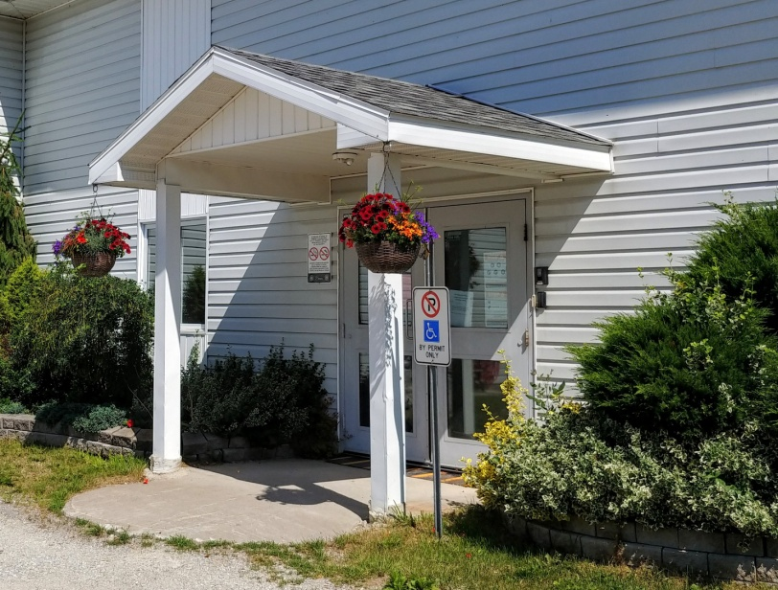
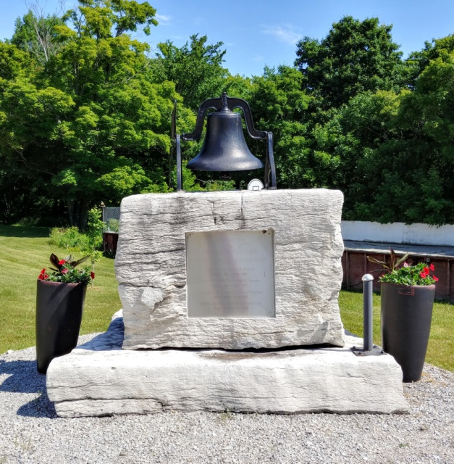
Members of the garden club have been busy planting and maintaining the gardens at the hall for all to enjoy. New volunteers are always welcome. If you are interested in joining the garden club, please call Seija Bailey at 705-282-8108.
