BURPEE & MILLS NEWSLETTER
April 2021
Council Report:
The next meeting of municipal council will be held on Tuesday, May 4th at 7:30 p.m.
The Burpee & Mills Township office is open to the public. The gym, hall and public washrooms remain closed.

COVID-19 Screening and Consent Forms:
Residents who have made appointments to get their COVID-19 vaccine shots should make sure to fill out the COVID-19 Screening and Consent form in order to speed up the process. These forms are available at the municipal office or you can download them from our website at www.burpeemills.com. You can book an appointment to get the vaccine by phone at 1-800-708-2505 between 7 a.m. – 9 p.m. or online at https://covid-19.ontario.ca/book-vaccine/. Be sure to mention that you live on Manitoulin Island.

Threatening Letters:
Our municipal council was disturbed and disappointed when informed that some of our neighbours had received threatening hate mail warning that they were not welcome and ordering them to leave our community. It is very disturbing that hard working peaceful people have been targeted in this manner. The township of Burpee and Mills, always welcoming to new residents, was dismayed when the so called “Protectors of Spirit Island” singled out some of our valued neighbours with these abusive letters.
The OPP Hate Crimes division is currently involved to determine the identity of the perpetrators so that they can be held accountable for this despicable act. Anyone who has received one of these hate letters is encouraged to contact council and report the situation to the police.

Private Water Supplies:
Spring weather is upon us! With the rain and warmer weather, snow and ice begin to melt and there’s an increased risk for surface and groundwater contamination. Public Health would like to remind anyone on a private water supply to make sure their water treatment system is functional and to perform any routine maintenance that is required in the manufacturer’s instructions. For example maintenance may include, flushing of water lines, changing filters and UV lights, and shocking your well.
Residents on a private well or treated surface water supply are also encouraged to submit a drinking water sample to the Public Health Ontario laboratory to ensure the water is safe for consumption.
Spring may also bring flooding which can be a concern for private water supplies and septic systems. For information on what to do in case of a flood, visit: https://www.phsd.ca/flood-prevention-and-cleanup-protect.../
Fire Team Report:
Residents are reminded that GRASS FIRES ARE NOT PERMITTED in our municipality. With many adults and kids at home in response to COVID-19 it is especially important to know what to do to ensure your home is fire safe.
Develop a home fire escape plan today…it could save your life tonight.

Install working smoke alarms on every storey and outside all sleeping areas of your home. It's the law!

Develop a home fire escape plan. Know what to do when the smoke alarm sounds. Sit down with everyone in your household and discuss how each person will get out of the home in a fire. Practise your escape plan with everyone in your home.
Make sure everyone can get out quickly. Make sure everyone knows two ways out of each room, if possible. If the door of a room is blocked by smoke or fire, discuss an alternate escape route such as a window. Make sure all windows open easily. Security bars on windows should have quick-releasing devices so they can be easily removed.
Help those who need it! Determine who will be responsible for helping young children, older adults, people with disabilities or anyone else who may need assistance.
Get low and go under the smoke to the nearest safe exit.
Most fire deaths are the result of smoke inhalation.
Choose a meeting place outside, a safe distance from your home.
A tree, street light or a neighbour's home are all good choices. In case of fire, everyone should go directly to this meeting place to be accounted for.
Get out, stay out.
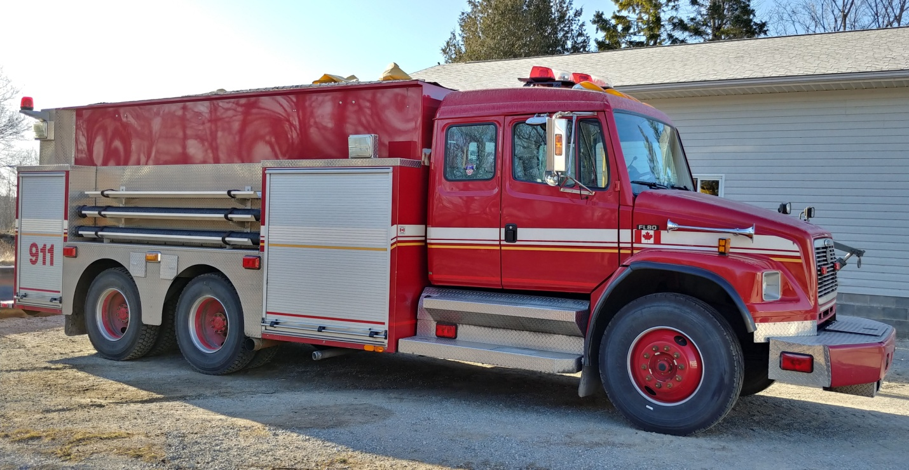
Never re-enter a burning building. Once you have safely escaped, call the fire department from outside your home using a cell phone or from a neighbour's home.
The Burpee Mills Fire Department now has a newer model pumper truck to replace the old one.

