BURPEE & MILLS NEWSLETTER
January 2021

Council Report:
The next regular meeting of municipal council will be held on Monday, February 1st at 7:30 p.m.
The municipal office is open to the public. Regular hours apply. In order to keep you and our employees safe, please use the hand sanitizer provided, wear a mask and be sure that there is only one person at the counter at a time. Please practise social distancing.
The gym, hall and public washrooms remain closed. For up to date information regarding our municipality, visit our website at www.burpeemills.com.

Golden Age Club Report:
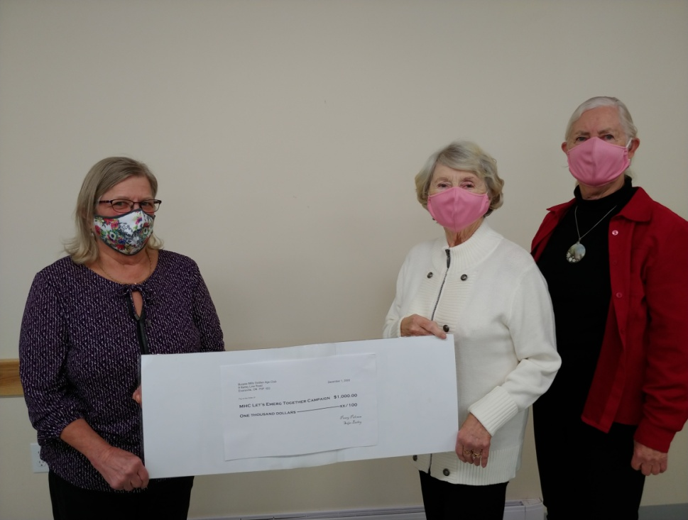
The Golden Age Club recently donated $1000 to the Manitoulin Health Centre’s “Let’s Emerge Together” campaign for the Mindemoya Hospital. Cora Hayden, a member of the MHC board of directors on the fundraising committee, is shown receiving the donation from Burpee Mills Golden Age Club secretary/treasurer, Seija Bailey, and president, Penny Palonen.
The Golden Age Club also sent a $500 donation to Manitoulin Family Resources to support the Christmas Basket Campaign to help those in need, especially this year during the pandemic.

Municipal Snow Removal:
Residents are requested NOT to push any snow from their driveways onto municipal roadways. These snow banks may freeze and create a serious hazard to the municipal snow plow and any other vehicles when they hit these obstructions. Please ensure that all snow is cleared off the road. Residents are also reminded not to park vehicles on the road allowance that could hinder the snow plow.

Road Safety:
Many of the Amish have installed flashing amber LED lights on their horse drawn buggies so that they will be more visible at night to those driving in faster vehicles. Remember to share the road, slow down and pass slower vehicles with caution. Be sure to take extra care when driving snow-covered and icy roads.

Fire Team Report:
Keep fire safety in mind as temperatures drop!
The Burpee Mills Fire Team is urging everyone to keep fire safety in mind as the temperatures turn colder. We often see more home fires during the winter months due to heating equipment and appliances. People need to pay close attention to potential fire hazards such as fireplaces, furnaces, chimneys and vents, and space heaters.

There are some simple things people can do to stay fire safe during the colder months:
- Have all fuel-burning appliances inspected annually by a registered fuel contractor.
- Keep chimneys and intake/exhaust vents for furnaces and heating appliances free of debris, ice and snow accumulations to reduce the risk of carbon monoxide (CO) build-up from inefficient combustion.
- Burn dry, well-seasoned wood in fireplaces and woodstoves to reduce the risk of excessive creosote build-up in chimneys.
- Allow ashes from your fireplace or woodstove to cool before emptying them into a metal container with a tight-fitting lid. Keep the container outside.
- Keep space heaters at least one metre (3 feet) away from anything that can burn, including curtains, upholstery and clothing.
- Replace worn or damaged electrical wires and connections on vehicles and extension cords and use the proper gauge extension cord for vehicle block heaters.
- Consider using approved timers for vehicle block heaters rather than leaving heaters on all night.
- Ensure that vehicles are not left running inside any garage or building.
- Ensure there is a working smoke alarm on every storey and outside all sleeping areas of your home.
- Install CO alarms to alert you to the presence of this deadly gas.

