BURPEE & MILLS NEWSLETTER
.
December 2022
Council Report:
The next regular meeting of municipal council will be held Wednesday, January 4th at 7:00 p.m.
The municipal office will be closed Friday, December 23rd until Tuesday, January 3rd for the Christmas season.

By-Laws:
Council has completed the First Reading of proposed By-Law 2022-08 Being a By-Law to manage Short Term Accommodations for the Municipality of Burpee and Mills.
The By-Law will be posted on the Municipal website for the public to review on or around the 15th December 2022.
The purpose of this by-law is to ensure that visitors to our community have a safe place to stay and owners of neighbouring properties are not impacted in a negative manner.
If you have any questions or comments, please direct them to:
Attn: Tim Bailey
burpeemillsbylaw@outlook.com
or call 705-862-2877

Municipal Snow Removal:
Residents are requested NOT to push any snow from their driveways onto municipal roadways. These snow banks may freeze and create a serious hazard to the municipal snow plow and any other vehicles when they hit these obstructions. Residents are also reminded not to park vehicles on the road allowance that could hinder the snow plow.

Holiday Fire Safety Checklist:
- Buy a fresh tree and keep the base of the trunk in water at all times.
- Lit candles should never be placed on or near the Christmas tree.
- Check all sets of lights before putting them on the tree. Discard any sets that are damaged or old.
- Stay in the kitchen when cooking. Unattended cooking is the leading cause of kitchen fires.
- Keep candles in a sturdy holder away from children, pets and combustible materials. Blow them out before leaving the room.
- Alcohol and fire are a dangerous mix. Keep a close eye on anyone attempting to cook or smoke while under the influence of alcohol.
- Encourage smokers to smoke outside. Check for cigarette butts between sofa and chair cushions before going to bed.
- Install smoke alarms on every storey and outside sleeping areas. Carbon monoxide alarms must also be installed outside all sleeping areas if your home has a fuel-burning appliance, fireplace or attached garage. Test the alarms monthly and change batteries at least once a year.

Community Events:

Saturday, December 10: Music Night at GG’s Diner with music provided by Beth and Joe Arnold. For reservations call 705-282-0244.

Saturday, December 17: Christmas Dinner at GG’s Diner with dinner music by Dave Southwood. Turkey Supper $20. For reservations call 705-282-0244.
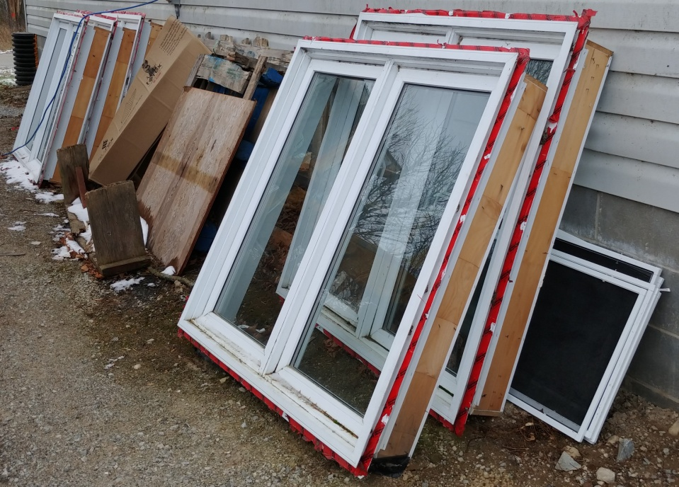
Surplus Windows:
Windows taken out of the municipal building during the construction of the new addition are now available for purchase. They can be viewed where they are sitting against the municipal garage. Sealed bids will be accepted at the municipal office until Thursday, December 15, 2022.

