BURPEE & MILLS NEWSLETTER

November 2022

Council Report:
The next regular meeting of municipal council will be held on Tuesday, December 6th at 7:30 p.m.
The newly elected council for the next term will be Reeve Ken Noland and Councillors Art Hayden, Kim Middleton, David Deeg and Roger Morrell.

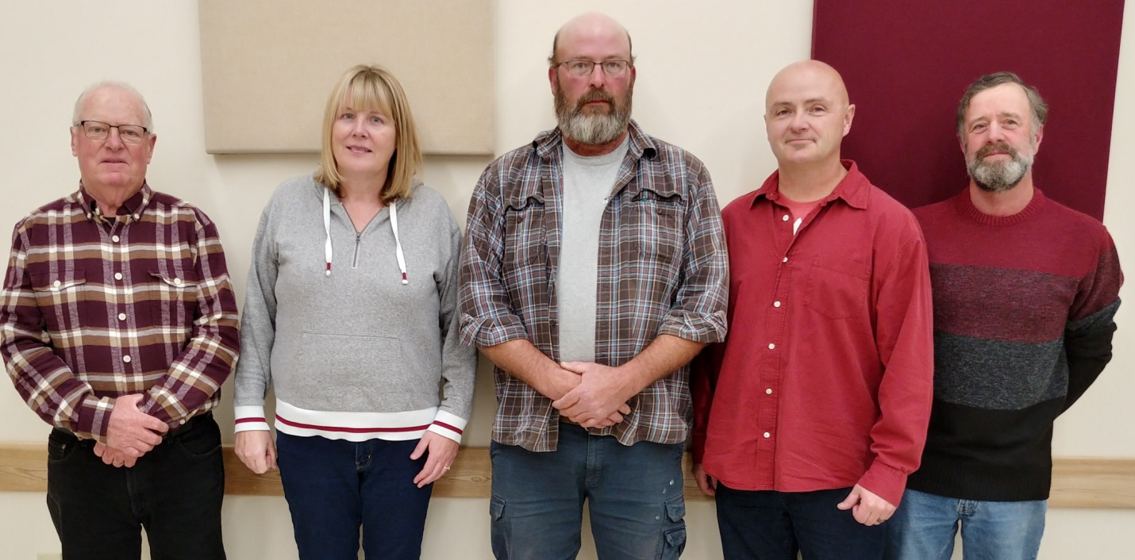

Municipal Snow Removal:
Winter will soon be upon us. Residents are requested NOT to push any snow from their driveways onto municipal roadways. These snow banks may freeze and create a serious hazard to the municipal snow plow and any other vehicles when they hit these obstructions. Please ensure that all snow is cleared off the road. Residents are also reminded not to park vehicles on the road allowance that could hinder the snow plow.

Burpee Mills Cemetery:
Thank you for your continued assistance in helping to maintain our cemetery as an attractive site for families to visit the final resting places of their departed relatives. Your monument floral arrangements, potted flowers, and solar light displays show other visitors how much you care. Now, with winter approaching, it’s time to check your interment sites to remove any potted plants or monument decorations that might be destroyed during the winter months.

Fire Team Report:
Clocks will fall back one hour at 2 a.m. on November 6. It is recommended that residents install new batteries in their smoke and carbon monoxide alarms when they change their clocks. In order for smoke and carbon monoxide alarms to do their job, they need to have working batteries. Once a year, old batteries should be replaced with new batteries.
In order to survive a fire, you need to be provided with an early warning and know what to do when the smoke alarms sound. Working smoke alarms are required on every storey of the home and outside all sleeping areas. For added protection, it is recommended to also install smoke alarms inside all bedrooms. Carbon monoxide alarms must be installed outside all sleeping areas if your home has a fuel-burning appliance, fireplace or attached garage.

Community Events:
Saturday, November 19th: Ellie Maxwell will sing during dinner which will be from the regular menu at GG’s Diner.

November 21st week: GG’s Diner will have extended hours for hunters during Hunt Week.

Saturday, November 26th: Dinner/Dance at GG’s Diner. Live music and band will be announced later. For reservations, please call 705-282-0244.

