BURPEE & MILLS NEWSLETTER
July 2022
Council Report:
The next meeting of municipal council will be held on Wednesday, August 3rd at 7:30 p.m.

Garden Club:
Members of the Garden Club have been busy planting and maintaining the gardens at the hall for all to enjoy. New volunteers are always welcome. If you are interested in joining the Garden Club, please call Seija Bailey at 705-282-8108.

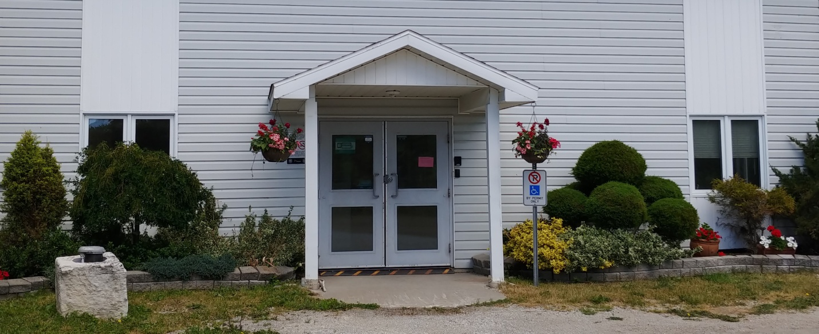

Household Hazardous Waste Day:
The Household Hazardous Waste Day will be on Saturday, July 23rd from 1:00 p.m. to 4:00 p.m., at 7 Lakeshore Rd. off Hwy 542/551 in Mindemoya (municipal road shed).
Please note that electronics waste will not be accepted at this time. Check the local newspapers for what to bring and what not to bring. For more information call the Mindemoya Office at 705-377-5726.

Line Dance Classes:
Joe and Beth Arnold are teaching beginner line dance classes at the Burpee Mills Municipal Hall. Come and join them for a night of good fun and exercise. There are three Friday night classes left: July 8th, July 22nd, and August 12th from 7 to 9 p.m. Email joebeth.arnold@gmail.com or call or text to 519-490-5686 to reserve your spot.

Summer Movie Nights:
Tom and Becky Prior have opened up their theatre/garage to host FREE movie nights this summer at 16712 Hwy 540. Movie nights are on Wednesday evenings at 7:30 p.m. July movies will be as follows: July 6th – Rocketman; July 13th – Peanut Butter Falcon; July 20th – West Side Story; July 27th – Parasite.

Fire Team Report:

Cottage Fire Safety – Tip Sheet
Install smoke alarms on every storey and outside all sleeping areas. It’s the law for all Ontario homes, cottages, cabins and seasonal homes to have working smoke alarms on every storey and outside all sleeping areas.
- Test smoke alarms at least monthly or each time you return to the cottage. Pack a new smoke alarm and extra smoke alarm batteries in case they need replacement.
- Install and ensure carbon monoxide alarms in your cottage if it has a fuel-burning appliance.
- Develop and practice a home fire escape plan to ensure everyone knows what to do if the smoke alarm sounds.
- Call 911 in case of fire and be sure to know your cottage’s civic number in case of emergency.
- Clean barbecues before using them. Keep an eye on lit barbecues and ensure all combustibles, as well as children and pets are kept well away from them. Fires can happen when barbecues are left unattended.
- Keep barbecue lighters and matches out of sight and reach of children.
- Remember to bring a flashlight with extra batteries.
- Check heating appliances and chimneys before using them.
- Check with your municipality, or Ministry of Natural Resources to determine whether open air burning is permitted before having a campfire or burning brush. If open burning is allowed, fires should be built on bare soil or on exposed rock. Remove leaves and twigs from around the fire to keep it from spreading. Always keep a bucket of water, sand, or even a shovel close by and supervise the fire at all times.
- If you must smoke, do so outside. Keep a large can with water nearby so cigarette butts can be safely discarded. If you drink, do so responsibly. Tobacco use and excessive alcohol consumption are contributing factors in many fires and can lead to serious injuries.
- Burn candles in sturdy candleholders that will not tip and are covered with a glass shade. When you go out blow out!!
Check the website www.burpeemills.com for up to date information regarding fire bans.

Community Events:

Sunday, July 10th – Elizabeth Bay United Church opens its doors for in-person worship at 1:30 p.m. for the first time since September 2019. Everyone is welcome to join this happy occasion.

Monday, July 11th – Movies in Meldrum, at the church, 7:00 p.m. Everyone is welcome to the screening of Philomena, starring Dame Judi Dench and Steve Coogan. This 20th Century Studios production won a 2014 BAFTA Award for Best Adapted Screenplay for its presentation of Ireland’s Philomena Lee and her relentless search for the son who had been taken from her as a toddler, and adopted out to an anonymous family in the USA. Based on a true story.

Saturday, July 23rd – Dinner/Dance at GG’s Diner, with music by Art Hayden’s band Family Tradition. For reservations call 705-282-0244.

