BURPEE & MILLS NEWSLETTER

**April 2022**

**Council Report:**

The next regular meeting of municipal council will be held **Tuesday, May 3 at 7:30 p.m.**

The Burpee & Mills Township office is open to the public. The office is open Monday to Thursday from 8:30 a.m. to 4:00 p.m. and is closed from 12:00 – 12:30 p.m. for lunch.

Please check the website at [www.burpeemills.com](http://www.burpeemills.com) for up to date information on when the municipal complex and gym will be open.

**Trailer By-law:**

RV Trailers currently situated on properties in the township as of 1 April 2022 without a valid 2022 Trailer Licence are now in contravention of the Trailer By-Law 02-2022 unless they are in a stored configuration at your primary residence.  Please review the Trailer By-Law 02-2022 ([www.burpeemills.com/municipality/by-laws/](http://www.burpeemills.com/municipality/by-laws/)) which highlights the process for compliance.  If you have already discussed your trailer with the By-Law Officer, please disregard this reminder.

If you have any questions, please contact: Tim Bailey, By-Law Officer, Municipality of Burpee and Mills at 705-862-2877 or [burpeemillsbylaw@outlook.com](mailto:burpeemillsbylaw@outlook.com) .

**Fire Team Report:**

Cooking is the number one cause of residential fires in Ontario. Don’t leave your cooking unattended. Stand by your pan. Keep an eye on your fries.

**Cooking Safety**

* Stay in the kitchen when cooking – especially if using oil or high temperatures.
* Keep a proper-fitting pot lid near the stove when cooking. If a pot catches fire, slide the lid over the pot and turn off the stove. Do not move the pan.
* Wear tight-fitting or rolled up sleeves when using the stove. Loose, dangling clothing can easily catch fire. If your clothing catches fire, stop, drop to the ground and roll over and over to put out the fire.
* Keep combustible items such as cooking utensils, dishcloths, paper towels and pot holders a safe distance from the stove.
* Keep children away from the stove. Make sure electrical cords are not dangling from countertops, where they could be pulled over by small children.
* Cool a burn by running cool water over the wound for 3 to 5 minutes. If the burn is severe, seek medical attention.

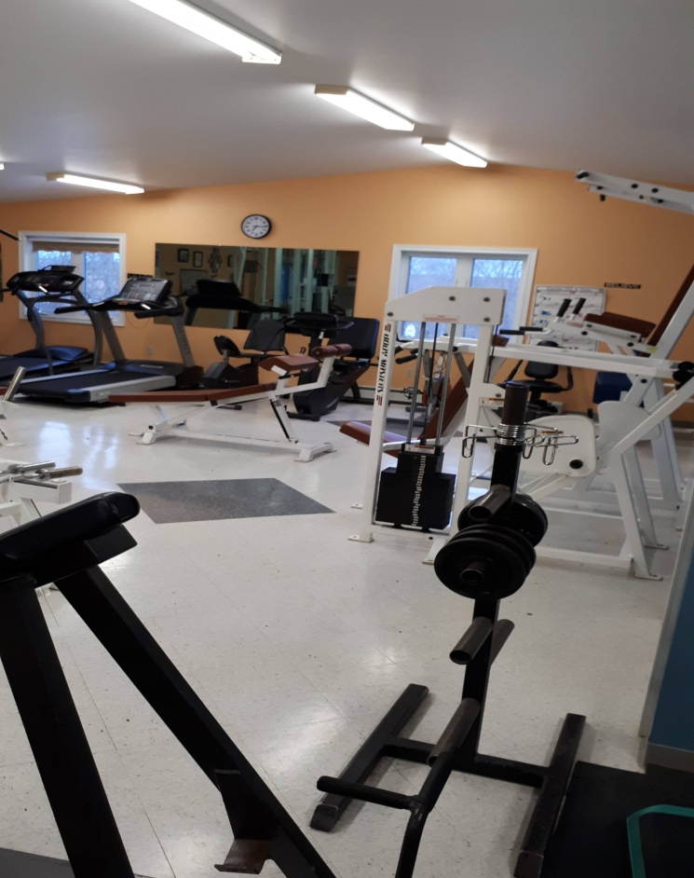**Burpee and Mills Gym:**

Our gym supervisors (a small group of volunteers) have met to assess the preparations required for opening of our gym facilities. Since the gym has sat inactive for a two year period, it was determined that prior to start up, a thorough inspection, cleaning and servicing of all equipment will be required, as well as revision of health and safety protocols for gym usage. The supervisors now project the possible opening of the facility during May. Until that time, we ask for your patience. Specific details regarding the opening will be noted in the municipal newsletter as well as Facebook articles.

**Water Safety:**

The Ministry of Northern Development, Mines, Natural Resources and Forestry – Sudbury District is advising area residents that a Watershed Conditions Statement - Water Safety is in effect in the District until Friday, April 08, 2022. Residents in the Sudbury District, including the communities of Sudbury, Espanola, the municipalities of Markstay-Warren, French River & St. Charles, Townships of SablesSpanish River & Baldwin, Town of Spanish and Manitoulin Island should exercise caution along local waterways. Although no flooding is anticipated based on current forecasts, special caution should be exercised around rivers and streams. Please alert and monitor any children under your care to these dangers and supervise their activities.

Water levels and stream flows across northeastern Ontario are moderately elevated due to ongoing snow melt and prior precipitation events. The snowpack is compacted due to previous rainfall, which has compromised its ability to absorb additional rainfall. Across northeastern Ontario watercourses that are free of ice are elevated as a result of the recent warmer weather. There is still snowpack across the region and lakes are still frozen. Warmer weather and rainfall will see rivers and streams respond accordingly.