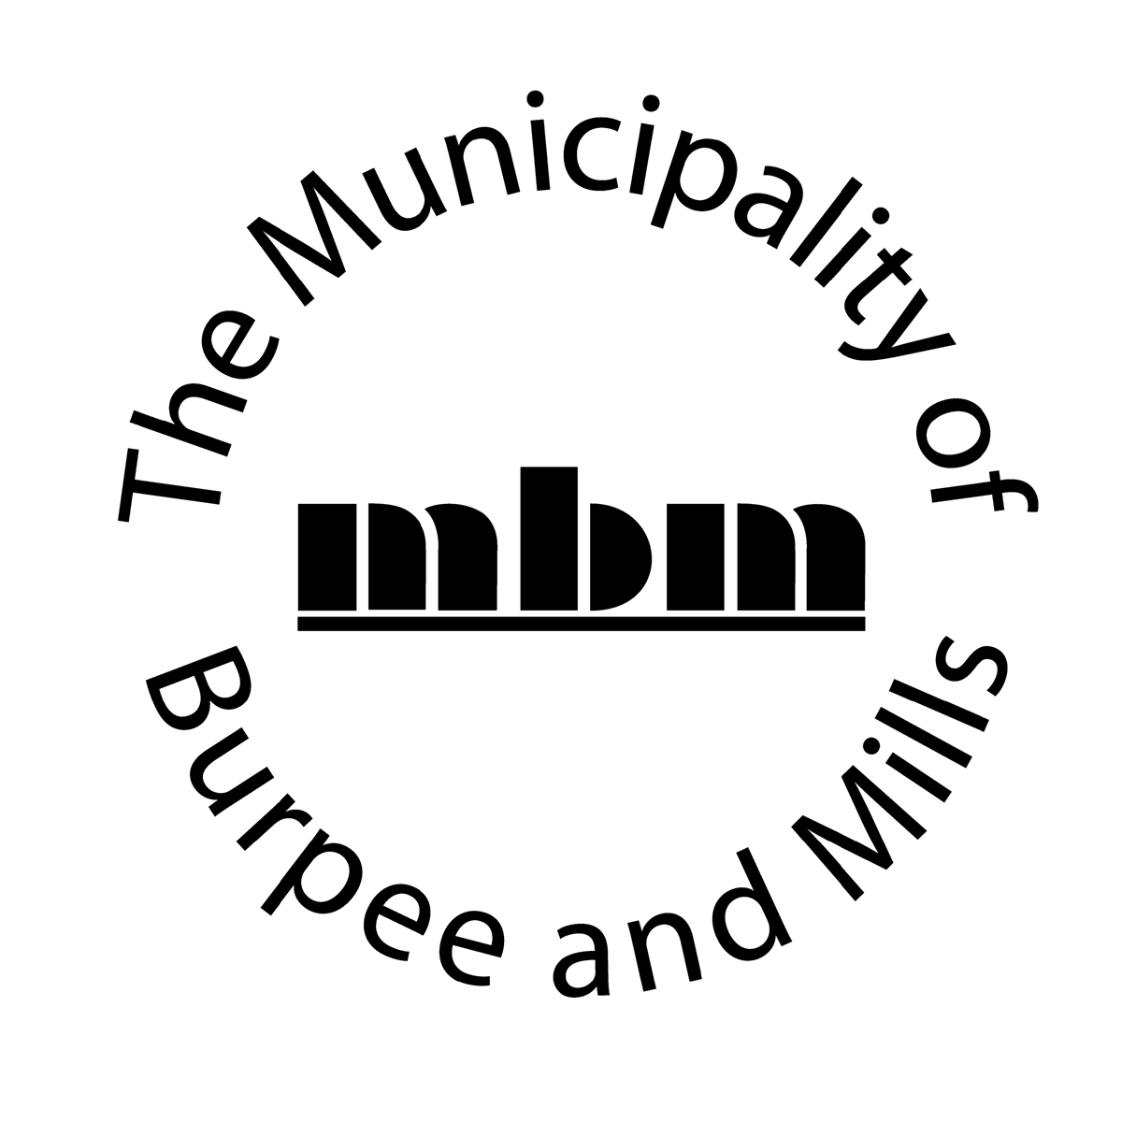

ACCESSIBLE CUSTOMER SERVICE, PROVIDING GOODS AND SERVICES TO PEOPLE WITH DISABILITIES, ACCESSIBLE EMPLOYMENT POLICY, ACCESSIBLITY PROCUREMENT OF GOODS, SERVICES AND FACILITES

Best Practices, Procedures And Policies
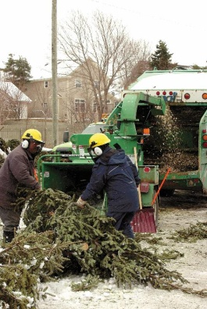

ACCESSIBLE CUSTOMER SERVICE

POLICY STATEMENT

The Township of Burpee and Mills strives at all times to provide its goods and services in a way that respects the dignity and independence of all people. The Township of Burpee and Mills is committed to giving people with disabilities the same opportunity to access our goods and services and allowing them to benefit from the same services, in the same place and in the same manner as other customers.

Exclusion – This Accessibility Customer Service Policy shall not apply during any period where the Municipality has declared a “State of Emergency” as defined under the Emergency Management Act.

PROCEDURE

The Township of Burpee and Mills will provide goods and services to people with disabilities, with particular consideration to the following areas:

- COMMUNICATION

The Township of Burpee and Mills will communicate with people with disabilities in ways that are sensitive to their disability. Staff who communicate with customers will be trained on how to interact and communicate with people with various types of disabilities.
The Township of Burpee and Mills will use the following preferred words and phrases, when dealing with disabled persons.

Instead of |  | Please use
Afflicted by cerebral palsy, multiple sclerosis, arthritis, etc. |  | Person who has cerebral palsy.  Person who has multiple sclerosis.  Person who has arthritis, etc.  Person with a disability.
Aged (the) |  | Seniors
Autistic |  | A person with autism.  A person who has autism.
Birth Defect, congenital defect, deformity |  | A person who has a congenital disability.  A person with a disability since birth.
Blind (the), visually impaired (the) |  | A person who is blind.  A person with a vision disability.  A person with vision loss.  A person with a visual impairment  A person with low vision.
Brain damaged |  | A person with a brain injury.  A person with a head injury.
Confined to a wheelchair, wheelchair bound |  | A person who uses a wheelchair.
Crazy, insane, lunatic, psycho, mental, mental patient, maniac, neurotic, psychotic, unsound mind, schizophrenic |  | A person with a mental health disability. A person who has depression.  A person with schizophrenia.
Cripple, crippled, lame |  | A person with a disability.  A person with a mobility impairment or, more specifically, a person who walks with crutches.  A person who uses a walker.  A person who uses a mobility aid.  A person with arthritis, etc.
Deaf (the), hearing impaired (the) When referring to the deaf community and their culture (whose preferred mode of communication is sign language) it is acceptable to use "the Deaf." |  | A person who is deaf (person with profound hearing loss who communicates using sign language.)  A person who is deafened (deaf later in life.)  A person who is hard of hearing (person with hearing loss who communicates primarily by speech.)  A person with a hearing loss.
INSTEAD OF: | PLEASE USE:
Deaf and dumb, deaf mute | A person who is deaf without speech.
Differently Abled | A person with a disability.
Disabled (the) | People with disabilities.
Elderly (the) | Seniors, older adults.
Epileptic | Person who has epilepsy.
Fits, spells, attacks | Seizures.
Handicapped (the) | Person with a disability.  The term handicapped may be used when referring to an environmental or attitudinal barrier as in "a person who is handicapped by a set of stairs leading to the entrance."
Hidden disability | Non-visible disability.
Invalid | Person with a disability.
Learning disabled, learning disordered, the dyslexics | A person with a learning disability or people with learning disabilities
Mentally retarded, idiot, simple, retarded, feeble minded, imbecile | A person with an intellectual disability. A person with a developmental disability.
Midget, Dwarf | A person of short stature. A person who has a form of dwarfism. A little person. A person diagnosed with "Achondroplasia, SED, or whatever their specific diagnosis is", a form of dwarfism.
Mongoloid, Mongolism | Person with Down Syndrome. One can use this terminology only when it is directly relevant.  A person with an intellectual or developmental disability.
Normal | Person who is not disabled. Person who is able bodied. Specifically, a person who is sighted, a hearing person, a person who is ambulatory.
Patient | Person with a disability. The word patient may be used when referring to a relationship between and medical professional and a client.
Physically challenged | Person with a physical disability.
Spastic | Person who has muscle spasms.
Stutterer | A person with a speech impairment or impediment.
Victim of/suffers from/ stricken with cerebral palsy, multiple sclerosis, arthritis, etc. | Person who has cerebral palsy. Person who has multiple sclerosis, etc. Person with a disability.
Visually impaired (the) | A person with a visual impairment. A person with low vision. A person with vision loss. A person with a vision disability.

PHYSICAL disabilities include a range of functional limitations from minor difficulties in moving or coordinating one part of the body, through muscle weakness, tremors, and paralysis. Physical disabilities can be congenital such as Muscular Dystrophy; or acquired, such as tendonitis. A physical disability may affect an individual’s ability to:

- Perform manual tasks such as holding a pen, turning a key or grip a door knob
- Move around independently
- Control the speed or coordination of movements
- Reach, pull or manipulate objects
- Have strength or endurance

Best practices and procedures for Customer Service:
There are many types and degrees of physical disabilities, and not all require a wheelchair. It may be difficult to identify a person with a physical disability.

Here are some tips on serving customers who have physical disabilities:

- Speak normally and directly to your customer. Don’t speak to someone who is with them
- People with physical disabilities often have their own way of doing things. Ask before you help.
- Wheelchairs and other mobility devices are part of a person’s personal space, don’t touch, move or lean on them
- Provide your customer information about accessible features of the immediate environment (automatic doors, accessible washrooms, etc.)
- Keep ramps and corridors free of clutter
- If a counter top is too high or wide, step around it to provide service
- Provide seating for those that cannot stand in line
- Be Patient. Customers will identify their needs to you

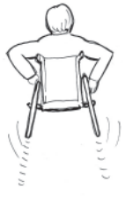

HEARING loss can cause problems in distinguishing certain frequencies, sounds or words. A person who is deaf, deafened or hard-of hearing may be unable to:

- Use a public telephone
- Understand speech in noisy environments
- Pronounce words clearly enough to be understood by strangers

Best practices and procedures for Customer Service:
Like other disabilities, hearing loss has a wide variety of degrees. Remember, customers who are deaf or hard of hearing may require assistive devices when communicating.

Here are some tips on service customers who are deaf or hard of hearing:

- Attract the customer’s attention before speaking. The best way is a gentle touch on the shoulder or gently waving your hand
- Always ask how you can help. Don’t shout. Speak clearly
- Be clear and precise when giving directions, and repeat or rephrase if necessary. Make sure you have been understood
- Face the person and keep your hands and other objects away from your face and mouth
- Deaf people may use a sign language interpreter to communicate – always direct your attention to the Deaf person – not the interpreter
- Any personal (e.g. financial) matters should be discussed in a private room to avoid other people overhearing
- If the person uses a hearing aid, try to speak in an area with few competing sounds
- If necessary, write notes back and forth to share information
- Don’t touch service animals – they are working and have to pay attention at all times

DEAF-BLINDNESS is a combination of hearing and vision loss. The result for a person who is deaf-blind is significant difficulty accessing information and performing daily activities. Deaf-blindness interferes with communication, learning, orientation and mobility. People who are deaf-blind communicate using various sign language systems, Braille, telephone devices, communication boards and any combination thereof. Many people who are deaf-blind use the services of an Intervener who relay information and facilitate auditory and visual information and act as a sighted guides.

Best practices and procedures for Customer Service:
Most people who are deaf-blind will be accompanied by an intervener, a professional who helps with communicating.

Interveners are trained in special sign language that involves touching the hands of the client in a two-hand, manual alphabet or finger spelling, and may guide and interpret for their client.

Here are some tips on serving customers who are deaf-blind:

- Do not assume what a person can or cannot do. Some people who are deaf-blind have some sight or hearing, while others have neither.
- A customer who is deaf-blind is likely to explain to you how to communicate with them or give you an assistance card or a note explaining how to communicate with them
- Do not touch or address the service animals – they are working and have to pay attention at all times
- Never touch a person who is deaf-blind suddenly or without permission unless it’s an emergency
- Understand that communication can take some time – be patient.
- Direct your attention to your customer, not the Intervener.

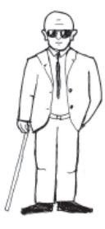

VISION disabilities reduce one’s ability to see clearly. Very few people are totally blind.
Many have limited vision such as tunnel vision, where a person has a loss of peripheral or side vision, or a lack of central vision, which means they cannot see straight ahead. Some can see the outline of objects while others can see the direction of light.
Vision loss can result in:

- Difficulty reading or seeing faces
- Difficulty maneuvering in unfamiliar places
- Inability to differentiate colours or distances
- A narrow field of vision
- The need for bright light, or contrast
- Night blindness

Best practices and procedures for Customer Service:
Vision disabilities can restrict your customers’ abilities to read signs, locate landmarks or see hazards. In some cases, it may be difficult to tell if a person has a vision disability.
Others may use a service animal or white cane.

Here are some tips on serving customers who have vision disabilities:

- Verbally identify yourself before making physical contact
- If the person uses a service animal – do not touch or approach the animal – it is working.
- Verbally describe the setting, form, location as necessary
- Offer your arm to guide the person. Do not grab or pull.
- Never touch your customer without asking permission, unless it is a emergency
- Don’t leave your customer in the middle of a room. Show them to a chair, or guide them to a comfortable location
- Don’t walk away without saying good-bye

INTELLECTUAL disabilities affect a person’s ability to think and reason. It may be caused by genetic factors such as Downs Syndrome, exposure to environmental toxins, such as Fetal Alcohol Syndrome, brain trauma or psychiatric disorders. A person with an intellectual disorder may have difficulty with:

- Understanding spoken and written information
- Conceptual information
- Perception of sensory information
- Memory

Best practices and procedures for Customer Service:
People with intellectual or developmental disabilities may have difficulty doing many things most of us take for granted. These disabilities can mildly or profoundly limit one’s ability to learn. You may not be able to know that someone has this disability unless you are told, or you notice the way people act, ask questions or use body language.

As much as possible, treat your customers with an intellectual or developmental disability like anyone else. They may understand more than you think, and they will appreciate you treating them with respect.

Here are some tips on serving customers who have an intellectual or developmental disability:

- Don’t assume what a person can or cannot do
- Use clean, simple language
- Be prepared to explain and provide examples regarding information
- Remember that the person is an adult and unless you are informed otherwise, can make their own decisions
- Be patient and verify your understanding
- If you can’t understand what is being said, don’t pretend. Just ask again
- Provide one piece of information at a time
- Speak directly to your customer, not to their companion or attendant

SPEECH disabilities involve the partial or total loss of the ability to speak. Typical disabilities include problems with:

- Pronunciation
- Pitch and loudness
- Hoarseness or breathiness
- Stuttering or slurring

Best practices and procedures for Customer Service:
Some people have problems communicating. It could be the result of cerebral palsy, hearing loss, or another condition that makes it difficult to pronounce words, causes slurring or stuttering, or not being able to express oneself or understand written or spoken language. Some people who have severe difficulties may use communication boards or other assistive devices.

Here are some tips on serving customers with speech or language impairments:

- If possible, communicate in a quiet environment
- Give the person your full attention. Don’t interrupt until they finish their sentence.
- Ask them to repeat as necessary, or to write their message.
- If you are able, ask questions that can be answered ‘yes’ or ‘no’
- Verify your understanding
- Patience, respect and willingness to find a way to communicate are the best tools

LEARNING disabilities include a range of disorders that effect verbal and non-verbal information acquisition, retention, understanding and processing. People with a learning disability have average or above average intelligence, but take in and process information and express knowledge in different ways. Learning disabilities can result in:

- Difficulties in reading
- Problem solving
- Time management
- Way finding
- Processing information.

Best practices and procedures for Customer Service:

- Learning disabilities are generally invisible and ability to function varies greatly – respond to any requests for verbal information, assistance in filling in forms and so on with courtesy.
- Allow extra time to complete tasks if necessary.

MENTAL HEALTH disabilities include a range of disorders however there are three main types of mental health disability:

- Anxiety
- Mood
- Behavioral

People with mental health disabilities may seem edgy or irritated; act aggressively; be perceived as pushy or abrupt; be unable to make decision; start laughing or get angry for no apparent reason.

Best practices and procedures for Customer Service:

- Treat each person as an individual. Ask what would make him/her the most comfortable and respect his/her needs to the maximum extent possible.
- Try to reduce stress and anxiety in situations.
- Stay calm and courteous, even if the customer exhibits unusual behavior, focus on the service they need and how you can help.

SMELL disabilities can involve the inability to sense smells or a hypersensitivity to odours and smells. A person with a smelling disability may have allergies to certain odours, scents or chemicals or may be unable to identify dangerous gases, smoke, fumes and spoiled food.

TOUCH disabilities can affect a person’s ability to sense texture, temperature, vibration to pressure. Touch sensations may be reduced or heightened resulting in a hypersensitivity to touch, temperature, or the opposite, numbness and the inability to feel touch sensations

TASTE disabilities can limit the experience of the four primary taste sensations; sweet, bitter, salty and sour. A person with a taste disability may be unable to identify spoiled food or noxious substances.

OTHER disabilities result from a range of other conditions, accidents, illnesses and diseases including ALS, asthma, diabetes, cancer, HIV/AIDs, environmental sensitivities, seizure disorders, heart disease, stroke and joint replacement.

Disabilities are not always visible or easy to distinguish.

ASSISTIVE DEVICES
The term “assistive devices” refers to an auxiliary aid such as communication aids, cognition aids, personal mobility aids and medical aids (i.e. canes, crutches, wheelchairs, or hearing aids).

- Accessible Telephone Service

If enquiries for telephone services are received for hearing impaired or vision impaired individuals, please refer them to Bell Canada. Teletype (TTY) is older technology and the municipality will not be purchasing any equipment for this purpose.

The Bell Relay Service operator is available to assist in placing or receiving calls to/from persons who use a TTY/teletypewriter. The operator will also assist in placing VCO (Voice Carry Over) and HCO (Hearing Carry Over) calls. VCO mode allows a person with a hearing disability to speak directly to the other party. HCO mode allows a person with a speech disability to hear the other party. There is no charge for local calls.

Information regarding this service is provided in the local telephone book under “Special Needs”.

- Electronic Door Openers

Add all locations with electronic door openers. This will vary greatly based on the resources of your Municipality.
If needed, separate the locations which have electronic doors that need to be turned on and turned off daily (see examples below)

The electronic door openers located at the following locations must be turned on at the beginning of the work day when the buildings are open and turned off when the buildings are not occupied:
a)
b)
c)
The motor in the electronic door openers at these locations will continue to run if they are pressed when locked and not turned off.

The electronic door openers located at the following locations do not have an off/on switch. These motors will not continue to run if pressed when the doors are locked:
a)
b)
c)
The electronic door openers do not have to be turned on in the morning or switched off when the building is not occupied.

- Accessible Parking and Accessible Ramps
(preferred parking is offered at all municipal building sites accessed by the public and is identified)

- Accessible Parking

The accessible parking places for all municipal buildings should be connected or integrated with a barrier-free path of travel, shall be painted blue and marked by an identifying marking consisting of the International Symbol for the Disabled (See below)

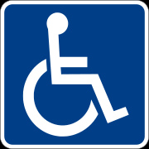

Wherever possible, the accessible path of travel shall be designed to avoid / minimize entering the vehicular routes and drives and be part of the shortest accessible route to the building or facility entrance.

The accessible parking places shall be cleared of snow as soon as practicable.

- Accessible Ramps

Accessible ramps at all municipal building locations shall be cleared of snow as soon as practicable.

- Municipality Website

Include what specialized software is included to assist individuals to access the website better. Attempt to use not only generic terms but also Trade Names as well so people know if their screen reading software or Braille output device is compatible.
The Municipality will develop a website that supports screen reading software.

When adding new information to the website, consideration should be given to:
- including a brief description for all pictures since the image description is read out loud by the program.

( a picture of a little boy wearing a blue bathing suit with a red/yellow life jacket and jumping into the water)

- making links descriptive of the destination they point towards. (i.e. http://www.loyalisttownship.ca/business-pdreview rather than http://www.loyalisttownship.ca/node/167)

- Municipal Elections

Municipalities must meet or exceed the accessibility requirements of the Municipal Elections Act and the barrier-free design requirements of the Ontario Building Code when addressing the accessibility of municipal voting facilities.

When making arrangements for municipal elections, The Township Clerk:
- Will provide election materials in accessible formats;
- Shall make such changes to some or all of the ballots as considered necessary or desirable to allow electors with visual impairments to vote without assistance;
- Shall have regard to the needs of the electors with disabilities when choosing a location for a voting location;
- Shall instruct a Deputy Returning Officer to attend on an elector anywhere within the area designated as the voting place, in order to allow a person with a disability to vote.

Municipal candidates must provide candidate materials in accessible formats.

- Council Meetings and Committee Meetings held in the Council Chambers

The Council of the Municipality do not currently use microphones as the council meetings take place is a small council chambers. Where hearing impairments are identified special provisions are made by council and staff on an as needed basis.
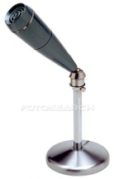

USE OF SERVICE ANIMALS AND SUPPORT PERSONS
Service animals, such as guide dogs, offer independence and security to many people with various disabilities. Some laws generally prohibit animals in certain areas (such as food preparation areas) however service animals are permitted in most public situations.
Support people assist people with disabilities in a variety of ways, by assisting with communication such as an intervener sign language interpreter, or as a Personal Support Worker providing physical assistance. A support person may also be a friend or relative that will assist and support the customer.
- Every employee shall use reasonable efforts to allow persons with disabilities to use their own assistive devices to access goods and/or services
- Every employee shall allow persons with disabilities to be accompanied by their guide dog or service animal unless the animal is excluded by law. Where an animal is excluded by law from the premises, the reason why the animal is excluded shall be explained to the persons with disabilities. Other reasonable arrangement to provide goods and services shall be explored with the assistance of the person with the disability.
- When a service animal is unruly or disruptive (jumping on people, biting, or other harmful behaviour) an employee may ask the person with the disability to remove the animal from the area or refuse access to goods or services. Other reasonable arrangements to provide goods or services shall be explored with the assistance of the person with the disability.
- Persons with disabilities may be accompanied by their support person while accessing goods and/or services.
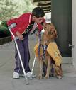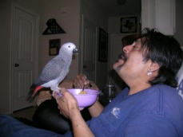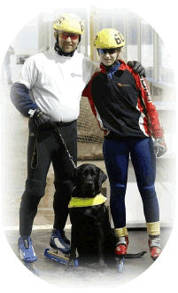

NOTICE OF DISRUPTION IN SERVICE

- Temporary Disruption in service

It is possible that from time to time there may be disruptions in service. If a disruption of service is planned, and expected, it is important to provide reasonable notice.

People with disabilities may often go to a lot of trouble to access services, such as booking transportation or arranging a ride. By providing notice, you can save that person an unnecessary trip.

Notice may be given by posting the information at a conspicuous place on premises owned or operated by Municipality, by posting it on the municipality’s website or by such other method as is reasonable in the circumstances.

- Unexpected Disruption in Service

In the event of an unexpected disruption in service, notice may be provided in a variety of ways and will be done as quickly as possible.

In the event of a service disruption, alternative methods of service may be considered and those impacted by service interruptions shall be informed of any alternative methods.

Procurement of Goods, Services, and Facilities

When procuring goods, services, or facilities, the Township shall incorporate accessibility criteria and features, unless it is not feasible (practicable). If not practicable, the Township shall provide an explanation, upon request.

ACCESSIBLITY EMPLOYMENT POLICY

POLICY STATEMENT

The Township of Burpee and Mills strives to support the full inclusion of persons as set out in the Canadian Charter of Rights and Freedoms, and the Accessibility for Ontarians with Disabilities Act, 2005. The Township of Burpee and Mills shall use every reasonable effort to ensure that we meet the needs of people with disabilities, in a timely manner following the principles of dignity, equal opportunity, integration, and independence.

Employment Standards
This policy applies to paid employees including but not limited to, Members of Council, full-time, part-time, and seasonal employment.
- Recruitment

The Township of Burpee and Mills shall post information about the availability of accommodations for applicants with disabilities in its recruitment process. Job applicants who are individually selected for an interview and /or testing shall be notified that accommodations for material to be used in the process are available, upon request. The Township shall consult with any applicant who requests an accommodation in a manner that takes into account the applicant’s disability. Successful applicants shall be notified about the Township’s policies for accommodating employees with disabilities as part of the offer of employment.

- Employee Supports

The Township will inform employees of the policies developed to support employees with disabilities, including policies on the provision of job accommodations that take into account an employee’s accessibility needs due to disability. The Township will provide this information to new employees as soon as practicable after they begin their employment and provide updated information to all employees whenever there is a change to existing policies on the provision of job accommodations that take into account an employee’s accessibility needs due to disability.

- Accessible Formats and Communication Support for Employee

Upon an employee’s request, the Township shall consult with the employee to provide or arrange the provision of accessible formats and communication supports for:

- Information that is needed in order to perform the employee’s job; and
- Information that is generally available to employees in the workplace.

The Township will consult with the employee making the request in determining the suitability of an accessible format or communication support.

- Workplace Emergency Response Information

If an employee’s disability is such that workplace emergency response information is necessary and the Township is aware of the need for accommodation, this information shall be provided to employees. In addition, this information shall be provided, with the employee’s consent, to the person designated to provide assistance. The information shall undergo review when the employee moves to a different location, when the employee’s overall accommodation needs or plans are reviewed and when the Township review its general emergency response plan.

- Documented Individual Accommodation Plans

A written process for the development and maintenance of documented individual accommodation plans shall be developed for employees with disabilities if requested, these plans shall include information regarding accessible formats and communications supports. If requested, the plans shall include individualized workplace emergency response information.

- Return to the Work Process

The Township shall have in place a documented return to work process for employees returning to work due to disability and requiring disability – related accommodations. This return to work process shall outline the steps that the Township shall take to facilitate the return to work.

- Performance Management and Career Development and Redeployment

The Township shall take into account the accessibility needs of its employees with disabilities as well as any individual accommodation plans when providing career development, performance management and when considering redeployment.

If you have any questions or concerns about these policies or its related procedures please contact:

Patsy Gilchrist, Clerk Treasurer
(705)282-0624
8 Bailey Line Road, Evansville, ON P0P 1E0
burpeemills@vianet.ca

This policy and its related procedures will be reviewed as required in the event of legislative changes.

